Worming fact sheet

The concept of strategic dosing to control worms in horses (i.e. worming all the horses in a yard at the same time, regardless of their individual worm burdens, at fixed intervals and rotating regularly between the active ingredients) goes back over forty years now. Despite this approach, many horses still have worms and multiple resistance to the routinely used anthelmintics is rising rapidly. Even in yards where certain drugs are still effective the ERP (the egg reappearance period, -the period where droppings remain free from eggs following a successful treatment with an anthelmintic), is reducing dramatically. This suggests that resistance continues to develop. Recent studies have shown that high levels of resistance (40-85%) exist to benzimadazole (Panacur), low to moderate levels of resistance (0-30%) to the pyrantels (e.g. Strongid P etc), and that currently there is very little resistance to the ivermectins (e.g. Eqvalan etc). The net result of this research demonstrates that only ivermectin and moxidectin are consistently our most reliable wormers. Unfortunately these chemicals are closely related to each other and there is already some evidence suggesting that Parascaris worms in foals are developing resistance to ivermectin. None of the above would be worrying if there were new classes of wormers constantly being developed to replace these products. However as far as I am aware there are no new ‘wonder wormers’ just over the horizon, (Ivermectin came onto the market in 1983 and moxidectin in 1995). Should any new wormers be developed, the high cost of licensing these products and the relatively small size of the equine wormer market suggests that they will be significantly more expensive that any of our current available anthelmintics. These depressing facts have led equine veterinarians to conclude that a new approach to controlling worms in horses is long overdue.

The large strongyles /redworms (e.g. Strongylus Vulgaris) were originally the major pathogens in the horse. The immature larvae migrated extensively through their bodies and they were considered to be a major cause of weight loss and colic. These species have now largely been controlled by the modern anthelmintics. They have been replaced by the small strongyles (cyathostomes) as the major cause of parasite related disease in horses. Nowadays small strongyles can account for virtually all of the worm eggs in horse droppings. Their larvae do not migrate through the body but can become encysted in the intestinal walls (essentially hibernating there) and emerge in waves in the spring, causing inflammation, weight loss, chronic diarrhoea and oedema. Once encysted these (hibernating) larvae are very difficult to treat, few modern wormers are able to act on them. Moxidectin is currently the only really effective wormer in removing these encysted larvae.

There is a lot of advertising in the equine press regarding the need to control tapeworms in horses. Whilst it has been shown that in certain circumstances horses with colic have tapeworms, these might just have been an incidental finding. Furthermore it is now believed that the blood test may just confirm exposure to tapeworms but not necessarily indicate a significant actual infection.

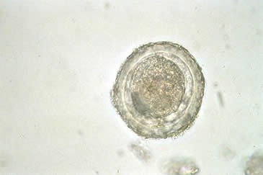
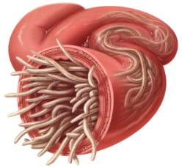
Parascaris equorum

In summary the current practice of treating all the horses in a yard for worms at fixed intervals without checking the ongoing effectiveness of the drugs, is not working and is promoting resistance. Most of our clients are wasting their money by treating horses that are not ‘particularly wormy’ or due to resistance they are using products that no longer work effectively.

Unfortunately we can offer no easy solutions to the above. Harrowing paddocks can work well in warm dry climates by exposing the eggs and larvae to desiccation. However in temperate climates it rarely (if ever) gets dry enough, for long enough to be truly effective. It simply spreads the infective larvae over an even larger area and may make a worm problem even worse. Worms have a life cycle. This means that the eggs in the droppings MUST develop into infective third stage larvae before they can become a danger to horses. Under ideal conditions in these climates this usually takes a minimum of four days. This can easily be prevented by picking up the droppings from paddocks at least twice weekly. Not only is this ‘character building’ for our clients, it saves them money and there can never be a problem with (drug) resistance. In general about 80% of the pasture contamination comes from approximately 20% of horses in a yard. This latter group must be identified and treated. The remainder of horses in any yard, harbour low numbers of worms which currently do not appear to cause them any health problems. As long as this group is not treated with anthelmintics, they help maintain a population of drug sensitive worms which helps in turn to slow the development of resistance.

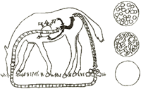
Lifecycle of large strongyles

Current recommendations:

- Get a faecal worm egg count from all new horses in a yard as part of the isolation process (treating them if necessary), before turning out into your paddocks. Retesting later, -see below.
- Keep stable numbers of horses in smaller paddocks and pick up the droppings at least twice weekly.
- Take faecal worm egg counts from all horses at least four times a year, (March, June, September and December). For batches of ten or more faecal samples please arrange a mutually convenient time with the clinic before taking them.
- Worm every horse with a worm egg count of over 150 eggs per gram with an effective wormer.
- Accurately calculate your horse’s weight before treating him and make sure that he does not spit out the wormer subsequently. Under dosing is a major contributor to the development of resistance.
- Retest all treated horses for drug resistance with a follow up worm egg count two weeks later.
- ‘Persistent offenders’ (i.e. Horses which frequently have high worm egg counts) should be tested (and treated if necessary) every two months.
- You may consider blood testing in the late summer for tape worms, -absolutely necessary?
- We currently recommend treating all horses with an Moxidectin/praziquantel (Equest Pramox ®) in December (after the first severe frost) for Bots.

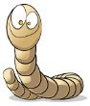



The Acorns Equine Clinic, Pleshey, Chelmsford, Essex. CM3 1HU.
Telephone (01245) 231152, Fax. (01245) 231601
www.essexhorsevets.co.uk

