.
Horse Insurance an owner’s guide.

We believe that as the cost of medical care for both humans and animals has become so expensive, all horses and ponies should be insured for both public liability and veterinary fees. This gives you, as a responsible owner the reassurance that any decisions you have to make regarding their futures will be as free from financial constraints as possible. Some policies also provide for ‘loss of use cover’ but these are usually significantly more expensive. Some insurance companies may offer high excess policies or multiple horse discounts.

You should choose your insurance company carefully and read all the terms and conditions of the policy both at inception AND on renewal. In our experience it is usually easier to discuss any exclusions which appear to be unreasonable whilst your horse is healthy and before any potential /pending claims. Some policies may not cover the full cost of hospitalisation, remedial farriery, physiotherapy, or even certain oral supplements (e.g. Synequin, /glucosamine etc). In general terms, you tend to get what you pay for in life, (i.e. the cheapest is not always the best value in the longer term). Stick to reputable companies only.

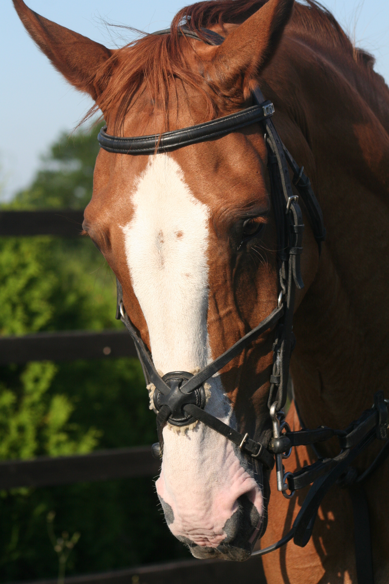

We feel it is especially important if you are considering putting your horse or pony out on loan, that you as the owner choose an appropriate policy with an individual company (and if necessary get the borrower to pay the premiums). This simple advice may save you a lot of heartache subsequently.

Unfortunately no veterinary practice can reasonably be expected to know exactly what is (or more importantly what is not) covered by an individual policy. Any individual exclusion applied will be based on your horse’s clinical /claim history. If you have used several different veterinary clinics over the years, no one practice will have a complete clinical history. We recommend that all owners keep a summary of their policy handy (in the horse’s passport?) so that it can be easily checked in an emergency situation. This will help clarify just what is (and more importantly what is not) covered by your insurance. The insurance companies can be very difficult (if not impossible) to contact out of hours or at weekends. If in doubt we recommend that any decision you make regarding veterinary treatment is based on the assumption that it will NOT be covered, rather than the reverse.

- The age at which full /normal cover now varies between companies, some will only provide full cover to sixteen years of age, before changing to a veteran policy.
- Veteran policies generally only cover you for accidental injuries. An accidental injury is defined by some companies, ‘as where there is a visible wound’. In other words if your horse is injured but does not have a visible wound, he may not be covered under the terms of these policies.
- The insurance companies often insist on being informed prior to any general anaesthetic being administered, (including routine castrations).
- You should always inform your insurance company as soon as possible of any injury or illness, irrespective of whether you intend to make a claim or not. Some companies may disqualify an otherwise valid claim if it is not reported within a predefined time limit! Also it is important to be aware that for most (if not all) insurance policies there are two limits for each claim. Firstly there is a financial limit, -usually of about £5,000, (you could easily spend all of your insurance money in the first 48 hours in surgical colic cases). But also there is usually a time limit of one year from the time that you as the owner first become aware of any problem. This could be a problem with difficult tendon injuries /long term arthritis etc.
- Many insurance policies will only pay out on ‘humane destruction’ if your veterinary surgeon can certify that he satisfies the BEVA fourteen point criteria. These are very strictly defined and basically mean that your horse was in severe incurable pain which necessitated immediate destruction to prevent unnecessary suffering, (eg. Twisted gut, certain fractures etc). Other conditions (eg inco-ordination etc), may not be covered although these horses may not be able to lead a normal life or could pose a danger to themselves and their handlers, this might be defined as a ‘loss of use’ under the terms of some policies. In non-emergency situations it is best to speak to the underwriters and to clarify their position before putting any horse to sleep.
- Should you decide to make a claim on your insurance policy we would ask you to promptly fill in your claim form and forward it to us (together with any other relevant invoices, (e.g. corrective /remedial farriery or physiotherapy etc).
- Our Veterinary staff (or practice manager Mrs Amanda Fenelon) will be happy to assist you as much as possible should you need to claim on a policy for veterinary treatment. However we have to point out that there are two contracts in law. We will provide your horse with veterinary care /treatment and invoice you in due course. Provided that you have a valid policy and this condition is covered, you can then reclaim your vet’s fees from the insurance company.
- In practice you can either pay us within 30 days of being invoiced (and in due course you will be reimbursed by the insurance company), or pay us the policy excess and tick the box on the form for the insurance company to pay us directly, (Please note that we will not do this with all Insurance companies, there are a few individual companies which are exceptions to this rule, so please ask us to confirm that in your individual circumstances this is acceptable to us).
- If there is a delay in payment by the insurance company or they need any further information, we will do our best to help you. But as the policy is a contract between you and the insurance company it is ultimately your responsibility to satisfy them that you have a valid claim. We treat thousands of horses each year and we cannot assume the responsibility of pursuing each individual claim.
- Even in chronic (long term conditions) e.g. a tendon injury, arthritis etc, you should promptly forward an initial claim form to the insurance company to be processed by them, followed by continuation forms in due course and receive a series of interim payments.
- If continuation forms are needed for any ongoing claims then please forward them to us (marked for the attention of Mrs Amanda Fenelon). She will then check that you have claimed for all that you are entitled to and forward them to the insurance company. She will keep a record as to what has been claimed for and may be able to answer any simple queries that the individual company may have.
- Obviously we hope that your horses will stay sound and healthy, but if they don’t, then we hope that you will find that this advice proves useful and minimises the stress of making a claim.



The Acorns Equine Clinic, Pleshey, Chelmsford, Essex. CM3 1QF.
Telephone (01245) 231152, Fax. (01245) 231601.
www.essexhorsevets.co.uk

