.
Vaccination.

Why vaccinate?

The most obvious reason is to prevent your horse becoming ill and unable to do his job. It helps to protect him from preventable infectious diseases. Any sick horse will require veterinary attention and could need costly treatment. A sick horse should not be ridden until he has made a full recovery. In cases of equine flu this could mean a loss of use for up to 12 weeks, with a consequent loss of fitness and could potentially even result in permanent damage to your horse’s performance. In diseases such as equine flu, vaccination plays a critical role in the prevention of disease spread. This is the concept of ‘herd immunity’. A group of vaccinated horses is better protected than just a single vaccinated individual in an unvaccinated group. This is due to the nature of infectious disease and is fundamental to the way that vaccines work. This is especially important in diseases such as equine flu and herpes virus. This is why it is important to keep your vaccinations up to date, not just for your own horse’s sake but for the welfare of the general horse population as a whole.

How does vaccination work?

Horse vaccines contain harmless forms of virus or bacteria. Following vaccination against a specific disease, your horse’s immune system generates protective antibodies against that organism. Then, if your horse meets that organism again in the future, he will be able to produce a faster and stronger immune response and is less likely to become ill and or pass on the disease to others. It is important that your horse is healthy at the time of vaccination so that his immune system can properly develop this protective response.

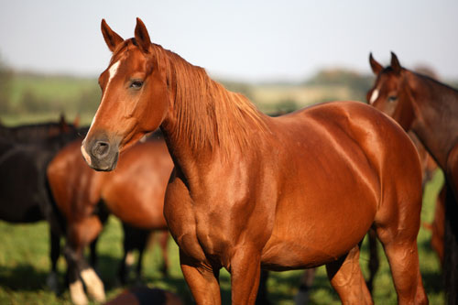

What is equine flu?

Equine flu is a highly contagious viral pathogen causing respiratory disease in horses all over the world. The disease is spread directly from horse to horse as airborne virus particles in the environment, or via contamination of equipment or clothing. Just like human flu the virus is constantly evolving, resulting in various strains causing disease in different outbreaks. With increasing international movement of horses a strain that might have caused disease in one country can soon appear in others. Strains are named after the location in which they were first discovered, (eg. Newmarket, Suffolk and South Africa etc).

What are the symptoms of equine flu?

The incubation period is approximately 1-5 days before symptoms start to become apparent. The clinical signs include a fever, which may be accompanied by a nasal discharge, followed by a cough. These typically last about 7-10 days, although the cough may persist for longer. Other symptoms include a loss of appetite, enlarged glands and muscular pain. A combination of the symptoms, coupled with the length of time required for a horse to fully recover from an infection can make this a severely debilitating disease. As the clinical signs of equine flu are similar to other respiratory viruses, diagnosis is confirmed by your veterinary surgeon by means of nasal swabs and blood samples.

What do I do if my horse gets flu?

The contagious nature of the virus will require that infected horses are isolated to try to limit the spread of the disease. It is important to contact your vet, not only to help ease the symptoms, but also for advice about returning him to work when he has recovered. Usually affected horses need at least six weeks rest, even if there are no complications such as secondary (bacterial) infections. Often this period needs to be much longer. The length of time that the horse is infected and rested after an infection will have major implications for the fitness of the horse and the preparation for competitions and events.

What can I do to prevent my horse getting flu?

Quarantine all new arrivals on yards. The best way to prevent your horse from getting flu is by vaccinating him. It is usually a requirement that competition horses are vaccinated against equine flu and that the boosters are kept up to date. It is important that all the horses on the yard are vaccinated as this helps the vaccine to work as effectively as possible. You can get all the information regarding vaccination timings from your vet. It is important to keep your horse’s vaccinations up to date, not only to prevent him from becoming at risk of infection, but also if a booster vaccination is missed your horse will need to have the primary course again, resulting in unnecessary expense. Good management and hygiene procedures are also essential to reduce the spread of the disease. Measurements such as sterilising transport vehicles and other equipment should be undertaken regularly.

Current jockey club guidelines for a primary course of flu vaccinations are as follows.
A first vaccine followed by a second vaccination given between 3 weeks to 3 months later, with a third booster vaccination 5-7 months after that. Annual boosters must be given within 12 months thereafter. Please note that individual manufacturers or competition regulations may differ. It is the individual owner’s sole responsibility to ensure that horses are vaccinated to the current regulations of their discipline.

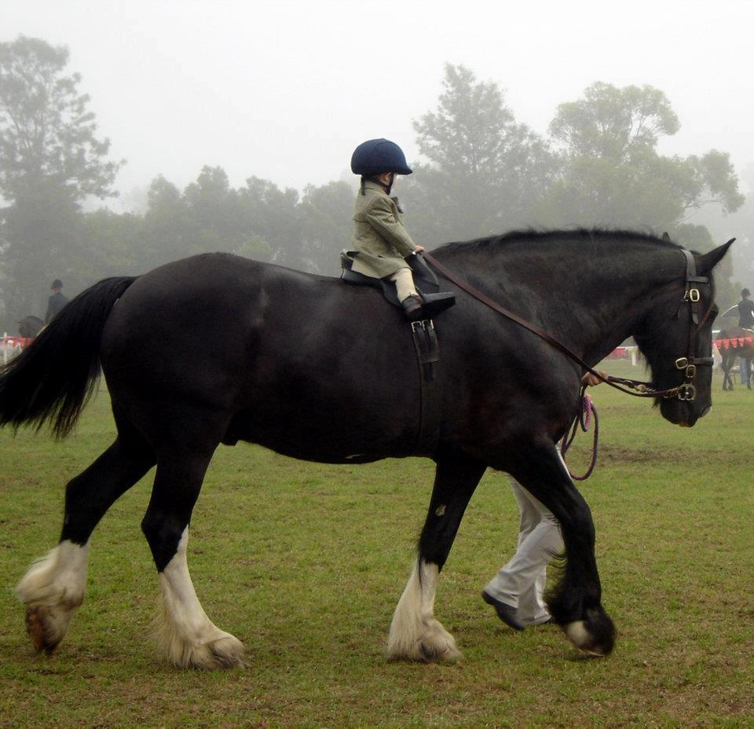

What is tetanus?

Tetanus is an acute and potentially life threatening disease of mammals characterised by stiffness and muscle rigidity. Unlike flu (which is caused by a virus), tetanus is caused by a bacterial infection. The tetanus bacterium (Clostridium tetani), can survive for long periods in the soil as a spore, which is highly resistant to heat and light. The bacteria can only multiply in areas with little or no oxygen, this usually means deep /puncture type wounds such as the classic nail in the sole of the hoof, which provides ideal conditions for bacterial multiplication. The organism produces a neurotoxin, which inhibits transmission of nerve signals within the body. The horse is the most susceptible of all the domestic animals to tetanus. NB. The Clostridial group of bacteria also includes another organism (Clostridium botulinum), which produces the toxin used in botox treatments in humans!

What are the symptoms of tetanus?

Clinical signs usually take between one and three weeks after infection to appear, with most cases between 5-10 days. A gradual progressive stiffness in the horse’s movement is typically the first sign, soon the affected horse is reluctant to move at all. Other signs include a ‘startled expression’, with flaring of the nostrils and a wide-eyed expression. As the infection progresses the horse will suffer from head spasms, -which make chewing difficult. Erect ears, tail held out and a very stiff body position are other symptoms. These will affect his movement, which will appear stiff and unsteady. Affected horses also have heightened reflexes triggered by sudden noises and movements. They easily become frightened and excited. They can go into violent general spasms. They have an increased body temperature, which can reach 43C (/109.5F). They will have an increased heart and respiratory rate, they may sweat profusely and have congestion of the mucous membranes.

Is tetanus infectious? And how is it transmitted?

Tetanus is not contagious, it cannot be passed from one horse to another. However the bacterium can survive in the soil and the environment for very long periods of time and should be considered to be ubiquitous. IT IS EVERYWHERE. Horses are at risk of infection from puncture type wounds.

How can I prevent my horse getting tetanus?

Prevention of the disease starts with good hygiene. The risk is minimised by checking and maintaining fencing, by clearing all potentially harmful materials from stables, paddocks and yards. Regular inspection of horses’ hooves and lower limbs for any injuries will help identify any potential sites of infection requiring treatment. Remember the fact that your horse does not compete is irrelevant to this disease. The risk is in the environment all around him, it just takes (an easily overlooked) puncture wound. It is impossible to avoid all injuries and vaccination is an essential factor in preventing tetanus. Your vet will be able to give you advice on vaccination programmes.

What is Equine Herpes Virus?

Equine Herpes virus (EHV) is a contagious viral infection, which can cause respiratory disease, abortions and neurological disease. There are two different types of EHV which can cause disease in horses.
EHV-1. This strain is less common, but can be severe in its effects, causing abortion and neurological signs as well as respiratory disease.
EHV-4. This strain is very common and causes respiratory disease.

What are the symptoms?

A rise in temperature is usually the first sign (41C /105.8F). Some nasal discharge, initially clear, but which may become thicker and mucopurulent as secondary infection occurs. Younger horses may develop a dry cough, although not as harsh or consistent as with equine flu. Affected horses may also show signs of depression and lethargy, looking uninterested with their ‘heads down in their boots’.
In breeding mares EHV-1 infection can seriously endanger the life of her foal. It is the most commonly diagnosed cause of infectious abortion. As previous infection can leave a horse as a carrier, the nature of the virus is such that there may be no clinical signs present in the mare prior to abortion. Abortions usually occur in the third trimester of pregnancy. The way in which EHV-1 may affect the nervous system can result in neurological disease. This is fortunately relatively rare, but affected horses can become paralysed, collapse and have a very poor prognosis.

How is it transmitted?

EHV is a contagious viral disease. It passes between horses through the respiratory tract by inhalation of the viral particles, shed by infected horses. As explained previously horses may become lifelong carriers of this disease and shed the virus at times of stress. In the case of abortion, the disease can be spread by the mare’s vaginal discharges, the infected foetus or the placental tissue.

What can I do to prevent my horse getting EHV?

Good yard management, in particular when dealing with potentially infected horses is the key to controlling the disease. Quarantine all new arrivals on yards. Reducing the potential stresses that set off disease spread is important as well as reducing issues such as overcrowding etc. Isolate sick horses if possible. Immunity even after natural infection is short lived and the carrier state is common. Vaccination plays a pivotal role in helping prevent the disease and reducing the amount of infective virus that is shed to other in contact horses. Your vet will be able to provide with specific advice relating to a suitable vaccination programme for your stables.



The Acorns Equine Clinic, Pleshey, CHELMSFORD, Essex. CM3 1HU.
Telephone (01245 231152), Fax (01245) 231601.
Esseshorsevets.co.uk.

