Sweet itch.

Sweet itch is an allergic reaction to biting midges (Culicoides spp.) and to certain biting flies (Simulium spp). It is very similar to flea bite eczema in cats and dogs. The female midges need a meal of blood before laying their eggs in soft mud. Unfortunately, from their point of view blood tends to clot, so they pump an anticoagulant (which is contained in their saliva) into the wound. Some horses become allergic to this saliva and exhibit the characteristic signs of the disease. These include intense scratching /rubbing of the mare and tail, (severely affected horses may also include other areas). Signs often begin at an early age and may become worse over time.

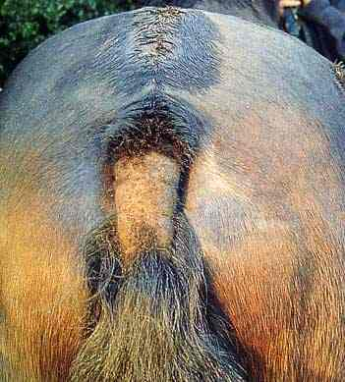

These insects breed in or near to stagnant water, are active during the warmer parts of the year (March to November), and are most active at dawn and dusk.

Control /treatment.

Sadly, there is as yet no cure for this condition, but it can be managed successfully. It is important to remember that as this is an allergic condition, symptoms can be triggered by the bites of only a very small number of midges. Control, therefore, depends on reducing, if not removing attacks by these insects. Affected horses should be stabled between 4 pm and 10 am, (midges are active at dawn and dusk). Fans fitted to the ceiling may help as the midges are weak fliers and don’t like air movement. The stables can be made insect-proof by using screens and insect repellent strips. Hoods and rugs (e.g. ‘Boett rugs’) reduce the body area exposed to biting. These may need to be worn between the months of March through to November.

Fly repellent or insecticidal sprays or creams should be used especially on the mane, tail, withers and head but also along the midline and neck. Examples of potentially useful repellents include ‘Switch’ (permethrin), ‘Deosect’, ‘Bug-off’, ‘Kill Itch’ (benzyl benzoate), Deet, citronella solutions etc. Insect repellent tags such as those used on cattle can also be attached to the horse’s head collar and may be beneficial in some cases.

These measures are not effective in all horses. Managing the environment can be important. The immature stages of these flies live in stagnant water so, if possible, affected horses should be moved away from areas where there is mud, wet sand, ponds, trees (providing shade), streams or rivers nearby. Leaking /overflowing water drinkers /taps etc should be repaired.

Cavalesse® can be helpful in some cases, this is a combination of an in feed medication together with a topical cream for spot treatment of lesions.

Topically applied creams and lotions containing antihistamines or corticosteroids (e.g. ‘Cortavance ®) spray’ can be useful but become very expensive for continual use. Topical oatmeal washes can help reduce pruritis.

Although an old treatment we believe that Benzyl Benzoate remains a very useful treatment, this lotion is applied topically (as well as being an insecticidal drug it also appears to sooth the inflamed skin).

Corticosteroids can also be given orally or by injection and long acting forms can give relief for several weeks in some cases. It is important to realise that corticosteroid treatment does not cure the condition but merely relieves the itching and that it can have serious side effects such as inducing laminitis and increased risk of infection. Nevertheless, in some cases, there is no alternative but to take these risks in order to relieve severe persistent distress and discomfort.

There is some evidence that supplementing the diets of affected horses with magnesium can be useful in some cases.

Allergen specific immunotherapy (hyposensitisation) is controversial, its success may vary with the presence of an adjuvant or the actual antigen used.

A few years ago, there was a lot of speculation that a vaccine might be just over the horizon, but as far as we are aware none has become available. However, there has been some evidence that the ringworm vaccine (Insol Dermatophytum) can be beneficial to horses affected by sweet itch. This is an ‘off the data sheet’ use. It is imported specially under licence to the UK. It consists of two vaccinations given deeply intramuscularly, fourteen days apart, starting before the midge biting season. Research suggests that 33% horses become ‘normal’, 33% ‘improve significantly’ and 33% ‘do not respond’. If you are interested you need to order it in early January, for injection in February.

The Acorns Equine Clinic, Pleshey, CHELMSFORD, Essex. CM3 1HU.
Telephone (01245 231152), Fax (01245) 231601.
Esseshorsevets.co.uk.

