Strangles.

Strangles is a highly contagious bacterial infection of the upper respiratory tract in equidae characterised by abscesses which develop in the throat region. It is caused by Streptococcus Equi. It is spread via pus or infected droplets by direct (horse to horse transmission) and indirectly (in water troughs, buckets etc). Good hygiene is fundamental in controlling any outbreak of this disease. The bacterium may survive for up to two months in water troughs. The incubation period is very variable (between 1-14 days), but is usually about a week. Infected horses may shed the bacterium BEFORE showing obvious clinical signs.

Clinical signs.

Affected horses are usually depressed, they quickly go off their feed (anorexia), have a high temperature (fever) and develop swollen lymph glands (which rupture) in the throat region, some affected horses may develop a ‘snoring type’ of respiration. Occasionally horses may suffer from a mild form of the disease where they just have a nasal discharge and swollen lymph nodes. Mortality is low. Occasionally affected horses may develop complications eg. Purpura hemorragica (petechial haemorrhages, severely swollen limbs, ventral oedema etc) or bastard strangles (multiple abscesses disseminated throughout the body). Recovered horses may become asymptomatic carriers for variable periods in their guttural pouches (throat region).

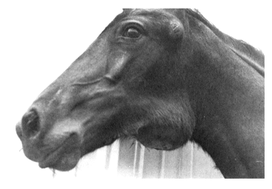

Treatment.

Treatment is very controversial and depends on the individual circumstances in each outbreak. This usually involves providing symptomatic relief (bute and topical hot fomentations /poultices etc). It may include a course of antibiotics (usually penicillin). Once abscesses rupture they can be flushed with dilute iodine solutions. Any confirmed or suspected case should be isolated along with any in-contacts immediately and placed under immediate veterinary supervision.

Control.

Carriers may shed the bacteria intermittently. They can be diagnosed by nasopharyngeal swabs (three swabs taken over a one /two week period) or more usually these days by a blood sample. Newly exposed horses can take up to two weeks to develop sufficient antibodies to be detected by the blood test, They may remain positive to the blood test for up to six months after they have recovered from the disease. It is very important to remember that no test is ever 100% accurate, (there can always be a small number of either false positive or false negatives). Carriers should have their guttural pouches washed out with antibiotics. All new arrivals into a yard should be isolated for up to three weeks before being introduced into the herd, or have a negative blood test result. Any horse that develops a nasal discharge or other signs suspicious of strangles should be immediately isolated and tested for the presence of Streptococcus Equi. We strongly recommend that affected yards close down with no new arrivals and no horses leaving the yard until the outbreak is under control.

There is a live attenuated vaccine for strangles, this is injected submucosally (in the upper lip. Veterinary advice should be sought to determine if the vaccine is available and whether its use may be appropriate on the basis of a specific risk assessment.

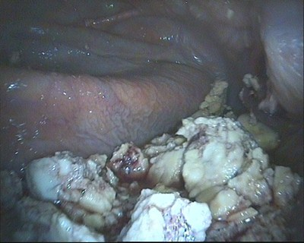

Strangles abscess’ in the guttural pouch.



The Acorns Equine Clinic, Pleshey, CHELMSFORD, Essex. CM3 1HU.
Telephone (01245 231152), Fax (01245) 231601.
Esseshorsevets.co.uk.

