Equine sarcoids

Sarcoids are probably the commonest skin tumour affecting horses. They are believed to be caused by the bovine papilloma virus. They are infectious but are not usually considered to be particularly contagious. There may be a genetic /familial predisposition to the condition (eg. Arab /appaloosa breeds) and biting flies have been implicated in spreading this disease, (=>isolate affected horses with open sores during the summer). They tend to be first noticed in younger horses (1-7 years) and in thin skinned areas (Eyes, axilla /groin areas).

Sarcoids can be classified into several different types,
- Occult, -roughened skin with small cutaneous nodules.
- Verrucous, -warty lesions, these may be flattened /pedunculated.
- Nodular, -firm, well defined subcutaneous spherical nodules.
- Fibroblastic, -these have a fleshy /ulcerated /reddened appearance.
- Mixed, -combinations of all of the above.
- Malevolent, -a more diffuse /locally invasive type of lesion.

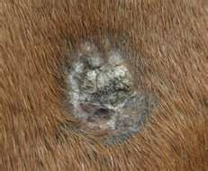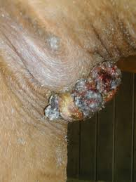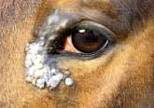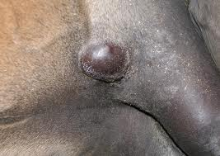

Many sarcoids present as single lesions which may remain inactive for prolonged periods. Others however may spread rapidly. These are skin tumours, -they DO NOT spread to the deeper body organs (ie. what you see is what you have got). It is often a very difficult decision as to how (and whether /not) to treat these lesions. It also poses difficult decisions in pre-purchase examinations, whilst a single lesion may not at present cause any problem for the proposed use of the horse, it could grow /he may subsequently develop other lesions which could. If you buy a horse with a sarcoid, it is unlikely to be covered by a veterinary insurance policy as it would usually be considered to be ‘a pre-existing condition’.
There is no universally accepted treatment for equine sarcoids. Small single lesions may remain stagnant for years (or even the life of some horses). However as a general rule tumours usually get bigger sooner rather than later. The bigger the tumour, the harder it becomes to treat successfully. Early single lesions usually have a much better treatment prognosis when compared to multiple lesions. In our opinion it becomes progressively more difficult to totally remove sarcoids after each successive treatment failure. Consequently we do not recommend ‘home remedies’ /self treatment by owners. Many treatments have been tried, few are without potential complications and success rates vary enormously. Repeated or prolonged treatments may be required. No horse can ever be considered to be free of this disease even after an apparently successful treatment, (ie. ‘remission rather than cure’). The exact treatment chosen will depend on the individual circumstances. Treatment approaches include.

- ‘Benign neglect’, (-ie. Leave alone for now and monitor for signs of growth).
- Ligation. (– cheap, may work well, especially with nodular sarcoids).
- Surgical excision (+/- cryotherapy), if the tumour is not completely removed, it may recur aggressively).
- LASER (either diode or CO2) surgery, (-as above).
- Topical Imiquimod cream (immune modifier, antiviral and antitumour cream).
- AW5-LUDES heavy metal and 5 Fluoracil ointment, (‘Liverpool Sarcoid Cream’) usually 3-5x topical treatments, over a period of about a week. Irritant and may cause scarring.
- Topical ‘Blood root’ ointment. (irritant and may cause scarring)
- Topical Aciclovir, Small /superficial lesions, -once daily for 2 months, not usually an irritant.
- Intralesional injections, (eg. BCG, -TB vaccine, 3x weekly injections, or Mitomycine C (an antibiotic!), -injected once every 8 weeks, /Intralesional, or Cisplatin injection, (-chemotherapy drug injected 3-4 times).
- Irradiation therapy, (Brachia therapy). Most successful treatment, very expensive.
- Photodynamic therapy, topical application of photo-reactive dyes, which are subsequently stimulated by light of a specific wavelength to destroy tumours. Usually two treatments about a week apart.

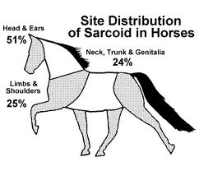



The Acorns Equine Clinic, Pleshey, Chelmsford, Essex. CM3 1HU
Telephone (01245) 231152, Fax: (01245) 231601
www.essexhorsevets.co.uk

