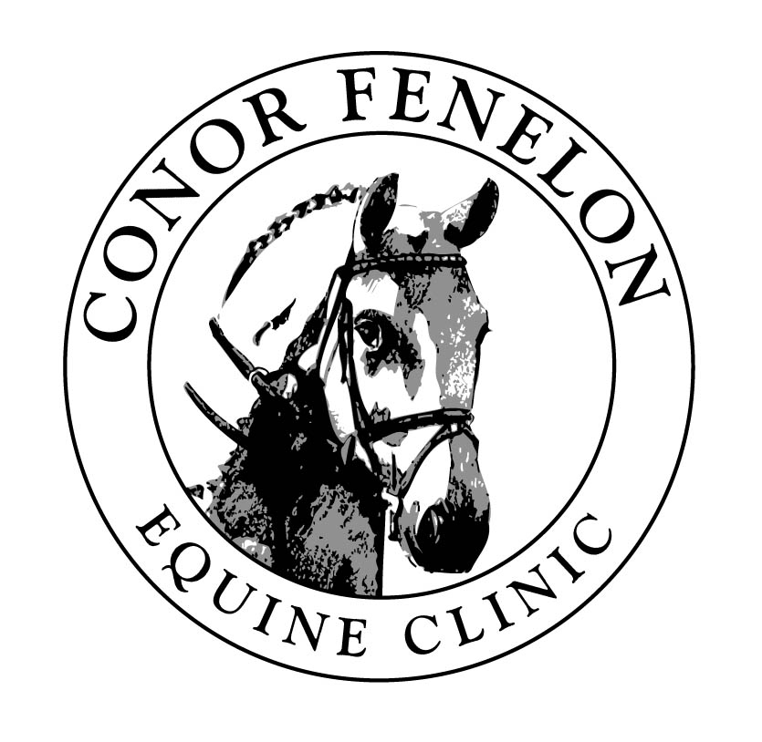

Pastern Dermatitis (Mud Fever)

Mud fever is a very common skin condition of the horse at this time of the year caused by mechanical injury to the skin of the lower limbs. Mechanical irritants include chronic moisture, frictional injury from bedding, tack, ectoparasites, microorganisms, etc. Inflammation of the skin gives rise to crust, scale, ulceration, lost of hair, granulation tissue, scarring, etc. Clinical signs vary and are dependant to both the origin and the stage of disease. It occurs mostly around the coronet, heels and pastern but it can also be found higher up on the limbs. Bilateral symmetrical involvement of the hind limb is the most common presentation.
The idea that mud fever is always caused by a single bacteria is no longer true. Although one species is often the primary cause, most cases are caused by a complex mix of several different bacterial species and potentially some fungal organisms. Unfortunately the diagnosis of mud fever is also complicated by other possible similar conditions. Most of these are much less common but the major problem is that mud fever may be part of a much wider systemic disease that affects skin amongst other organs. That is one of the reasons why it is important to establish a full diagnosis, only then can specific and effective treatment be given.
The treatment must be set out to achieve two main goals: establish and eliminate the primary and perpetuating cause(s) and treat the skin damage. Early veterinary attention will help considerably. No single therapy applies to all cases and each horse has to be seen as an individual but here are some basic treatment principles:

- Prevent further contact with the wet or mud. (Stable affected horses).
- Clip the affected area: improves topical treatment absorption and allows the skin to breathe/ and dry out.
- Remove scabs: warm wash with a medicated shampoo, such as Coatex® Medicated Shampoo, allow to stand for 10 minutes before rinsing and then thoroughly dry with paper towel. Note: Do not pick off dry scabs. If scabs are difficult to remove cover the affected area in a cleansing ointment such as Dermisol® then cover with cling film and stable bandages for 12 hours and re-wash as described above.
- Apply an antibacterial cream in order to prevent further infection and encourage skin healing.
- Continue once to twice daily for a week.
- If any signs of clinical deterioration or lack of improvement i.e. the horse becomes lame, cellulitis, etc. call us as soon as possible as your horse may need a course of antibiotics and/or the condition to be further investigated. For example, if predominantly white legs are affected it is suggestive of solar/ photoactivated dermatitis (Liver disease, /immune mediated disease etc). In that case you need to keep your horse out of UV light until a definitive diagnosis is made.

If you believe your horse or pony may be suffering from mud fever please contact us.

The Acorns Equine Clinic, Pleshey, Chelmsford, Essex. CM3 1HU
Telephone (01245) 231152, Fax (01245) 231601
www.essexhorsevets.co.uk

