Laminitis Fact sheet:

The pedal bone is suspended within the hoof capsule and transfers the weight from the skeleton to the ground via the laminae. Laminitis is a degenerative condition affecting these laminae. When a horse has laminitis, the laminae separate and this attachment apparatus fails. Consequently, the pedal bone becomes unstable within the hoof capsule. The weight of the horse and the forces of locomotion drive the bone down into the hoof capsule. Important arteries and veins are sheared and crushed and the corium of the coronet and sole is damaged. Severe and unrelenting pain occurs and a characteristic type of lameness develops.

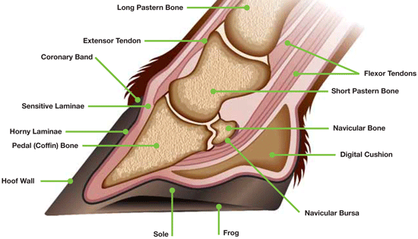

Laminitis has many causes. Classically it occurs in overweight /native type ponies, it is especially prevalent when the sugar (fructan) content in the grass is abnormally high, it can be caused by eating unusually large amounts of cereal (eg. Barley poisoning), in certain infections (e.g. metritis, peritonitis), or it may be caused by concussion /by adverse reactions to certain drugs including corticosteroids, etc. However, we now believe that the vast majority (possibly between 85-90%) of affected /susceptible horses have either Cushings disease or Equine Metabolic Syndrome (EMS) /Insulin resistance (or both -please see our factsheets available from this site).

We still do not completely understand the exact mechanism by which the lamina separate and which ultimately results in the pedal bone becoming unstable within the hoof capsule. This can result in either rotation or sinking (/foundering) or even a combination of both of the pedal bone within the hoof capsule.

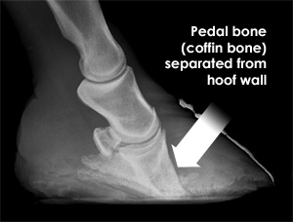

Rotation of the pedal bone.

How can I recognise the early signs?

In mild cases of laminitis, the horse or pony may appear slightly ‘pottery’. The forelimbs are most commonly affected although it is possible for the hindlimbs only or all four feet to be affected. Often one foot is worse than the others. The affected foot or feet may appear abnormally warm to the touch and the pulse taken at the heels may appear particularly strong. Laminitic horses will often stand with hindlimbs well under the body and forelimbs stretched out in front, (in an effort to keep weight off the painful front feet). This characteristic stance is almost diagnostic of laminitis. Affected horses will move with their heels landing first to try to avoid concussion to the painful toe region. If all four feet are affected, they may lie down for long periods or may constantly lift their feet alternately from the ground (almost as if they are standing on a ‘hot plate’). More severe cases result in inability or reluctance to move at all and horses with severe rotation and sinking will often be unable to bear any weight on the affected limb or limbs.

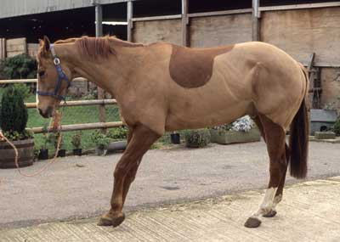

Horses which have recovered from laminitis, or chronic (long-standing) cases often have an altered hoof shape with long heels and a convex rather than concave sole. These horses must be monitored very closely for signs of foot pain and require regular remedial farriery.

It is important to realise that laminitis can progress from mild to severe even if early treatment is instigated. Early warning signs must be heeded and action taken immediately. We recommend X-Rays to confirm the diagnosis, to assess the severity

of the condition (prognosis) and to enable a prompt and ‘bespoke treatment’ to be instituted at the earliest opportunity.

Treatment of laminitis

Unfortunately, there is no single magic treatment for this condition and sadly there is still a high rate of mortality (especially amongst horses). The principals of treatment are fairly straightforward.

- Firstly, try to diagnose the underlying cause of the laminitis (eg. Cushings disease /EMS etc) and treat it accordingly.
- Support for the pedal bone within the hoof capsule, this can be achieved in a variety of ways (e.g. frog support, /sole support or a combination of both) and each case is different. See above re X-Rays.
- He should be box rested in a deep soft bed, to encourage him to lie down.
- We currently believe that the amount of pain exhibited is a good indicator of the degree of laminar damage, (even if the pedal bone is in a normal position when checked by x-rays). This is also a good indicator of the response to treatment.
- Pain relief, -given that the pedal bone is unstable within the hoof capsule, making a horse pain free, could encourage movement which in turn would increase the destabilising forces within the hoof capsule. Ideally, he should lie down and take the weight off his feet as much as possible. At our clinic we currently aim to ‘manage’ rather than to completely abolish the pain of laminitis.
- Feed a good quality hoof supplement, (e.g. Farriers Formula or Formula 4 Feet) to ensure that the laminae have all the micronutrients that they need.
- Overweight horses (as they cannot be exercised) must be dieted. They should be fed a diet of well soaked hay (12 hours) together with Laminitis Trust approved feeds, (e.g. Baileys ‘Lo Cal Balancer’, Spillers ‘Happy Hoof’, or Dengie ‘Hi Fi Lite’). We recommend that they are dieted in a controlled fashion, aim to feed between 1.3-1.5% of his target body weight (on a dry weight basis) as his total daily intake.
- ACP (a tranquilliser) often helps by sedating them slightly, making them less likely to box walk and perhaps even encourage them to lie down more, -taking the weight off their feet. It also seems to help the peripheral tissues to utilise glucose.
- Horses with Cushings disease need to be identified (blood tests) and treated appropriately, e.g. with Pergolide, (‘Prascend’ ‘Peroquin’) tablets etc.
- Horses /ponies with Equine Metabolic Disease (/Insulin resistance), need to be identified (blood tests), dieted and are often treated with Metformin etc.

There are many ways of shoeing horses and supporting the pedal bone in laminitis and each case should be treated as an individual. Sometimes it is a matter of trial and error to find the shoe that fits an individual horse. In acute cases we often use EDSS support pads together with Imprint shoes® to support the pedal bone (on occasions we also use Styrofoam or frog supports), /Clogs etc. Later on, we often like to use bar shoes with sole packs. EDSS shoes, heart bars and occasionally reverse shoes with sole packs can also be used depending on the individual circumstances.

We sometimes have to hospitalise chronic or refractory cases, as these have a tendency to develop abscesses or serroma’s, both of which need to be drained. Some

horses need surgical resection of the dorsal wall of their feet when the laminae separate completely in this area. A controversial treatment is to resect (cut) the deep digital flexor tendon in chronic or refractory cases. In the past this has been used as a salvage treatment but new evidence suggests that if it is attempted earlier in the disease process some horses may go on in due course to return to work and even compete successfully.

As we said there is no single treatment that is universally successful, sometimes it just comes down to patience and persistence. One rule of thumb that we believe in, is that the degree of pain seems to reflect the degree of damage to the laminae, we currently recommend that a horse remains box rested and comfortable for at least four weeks after he has stopped all pain relief before considering turning him out or returning him to work. It is also important in Cushings disease cases to check that the dose of Pergolide is correct, with follow up blood testing at appropriate intervals. In many respects we believe that laminitis has some similar characteristics to cancer in that neither ever seem to recover completely, it is almost as if it ‘just goes into remission’. A close eye MUST always be kept on their body condition and their feet so that any signs of recurrence can be identified at the earliest opportunity.

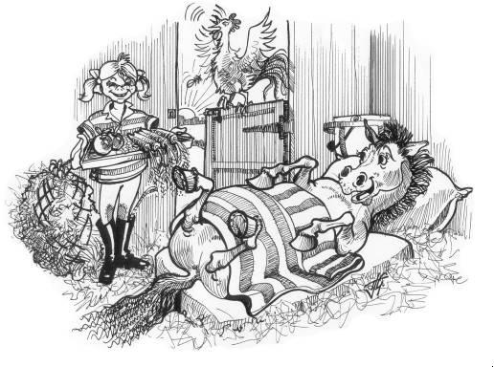



The Acorns Equine Clinic, Pleshey, CHELMSFORD, Essex. CM3 1HU.
Telephone (01245) 231151, Fax. (01245) 231601.
www.essexhorsevets.co.uk

