Equine Gastric Ulcer Syndrome (EGUS)

Gastric ulceration is an extremely common condition affecting all types of horses. While the clinical relevance of gastric ulceration is unclear in some cases, gastric ulcers can produce a variety of abnormal clinical symptoms. The risk of gastric ulceration varies with breed, use and level of training, and it is normally triggered by management changes, an increase in training intensity, high carbohydrate diets and stressful situations (i.e. transport, shows, windsucking etc.). Horses suffering from this condition often display vague /nonspecific signs including weight loss, mild recurrent colic, selective/poor appetite, dull coat, attitude changes, resistance to being ‘girthed up’ and decreased performance. The severity of ulcers can vary and mild ulceration may cause few clinical problems, however deep and extensive ulcers are likely to cause significant discomfort.

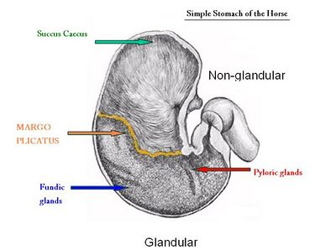

Figure -1.

The horse has a small stomach (about the size of a rugby ball). The upper third (squamous part) contains no glands, it has minimal protective mechanisms and mainly serves as a reservoir feeding fibre (eg. Hay etc) down into the lower 2/3 of the stomach, (the glandular part, where the process of digestion actually starts). The glandular part produces hydrochloric acid. This fibre physically protects the lining of the squamous part of the stomach from coming into contact with the acid, especially whenever your horse is exercised (and splashes it about). There is a visibly defined junction, between the two parts of the stomach (the margo plicatus). The glandular part of the stomach has numerous glands responsible for acid secretion and is also responsible for the production of acid-retarding bicarbonate, it has a mucous layer that protects its surface. Most of the ulcers occur in the area near to the margo plicatus. - Figure 1. However, it must be noted that ulcers can occur on either the squamous OR the glandular part of the stomach. It now appears that these may be two distinct AND separate conditions.

Ulceration is not just a disease of performance horses, 36-53% of pleasure horses and ponies are also affected. Foals are at particular risk of gastric ulcers, especially as a consequence of other medical conditions. Horses (and especially ponies) on long term bute may be at risk of developing gastric ulceration. You can estimate the risk to your horse using the website www.equinegastriculcers.co.uk.

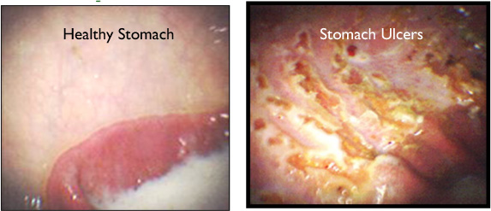

Gastroscopy is the only way to reliably diagnose and grade the severity of ulceration. The horse must first be fasted for a minimum of 12 hours, (water is withheld for a minimum of four hours), this procedure involves passing a flexible camera into the horse’s (empty) stomach. A positive diagnosis allows us to suggest appropriate management strategies and to establish the most cost-effective treatment plan.

If ulcers are diagnosed they should be treated with anti-ulcer medications (eg. Omeprazole, -this reduces the production of acid, allowing the ulcers to heal). Oral omeprazole appears to be most effective when administered first thing in the morning, (about 20-30 minutes BEFORE breakfast). Spontaneous ulcer healing can occur, but drug therapy is vital in most cases, and is effective regardless of training intensity. The treatment of glandular ulcers is much more difficult and often necessitates the use of Sucralfate and or Misoprostol in addition to the omeprazole. Management measures are just as important when treating EGUS. These include reducing stress, (eg. Constant access to clean water, feeding ‘calmers’, /mirrors in the stable etc). Constant access to a high fibre diet (alfalfa /grass /hay, -fine weave nets?). Feeding intervals of over six hours increase the risk of developing EGUS five fold. It is generally assumed that grazing reduces the risks of EGUS. However severe lesions have been found in pasture kept horses, (fructans, /bullying?). Feeding 50 -100 mls of corn oil twice daily can be helpful. Feeding a couple of handfuls of chaff or alfalfa cubes just before exercise helps prevent acid splashing onto the walls of an empty stomach. Recent research suggests that as acid production has a circadian rhythm feeding 80% of a horse’s daily hay during the day and just 20% at night helps reduce the acid damage especially to the squamous part of the stomach. Please note that any management /dietary changes instituted after the diagnosis of EGUS should be considered to be permanent. A follow up examination is needed to confirm resolution of the lesions. We usually recommend longer term gastric protectant type medications to help prevent recurrence, (eg. ‘Acorns Gastric Aid’).

Gastroscopy can be booked at any time. If you believe your horse or pony may be suffering from EGUS please contact our receptionists (01245 231152) to make an appointment.

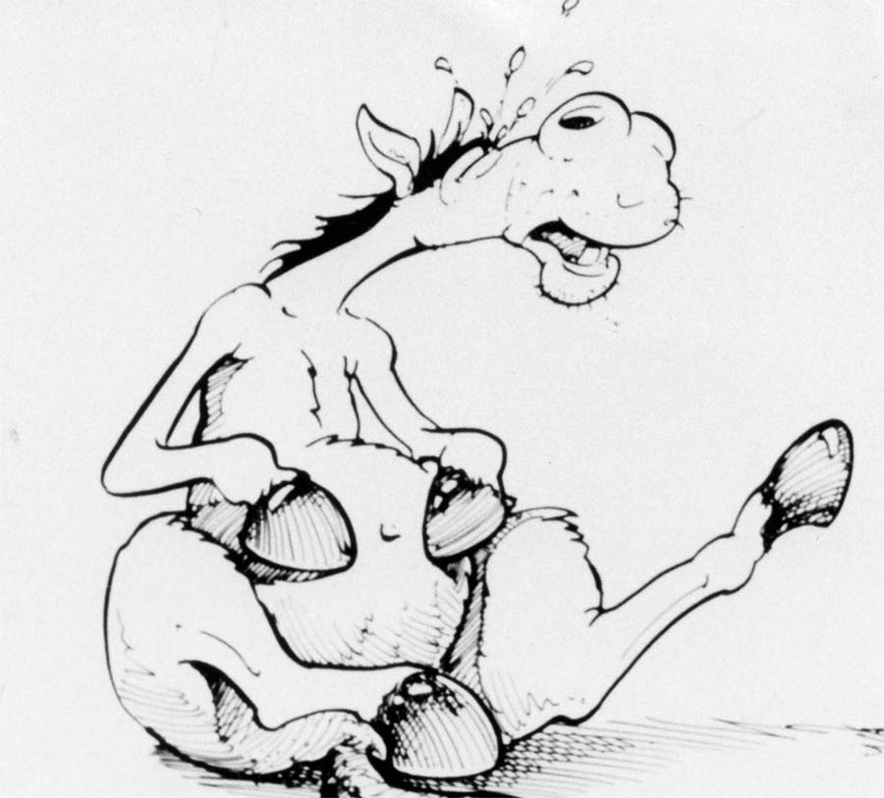



The Acorns Equine clinic, Pleshey, Chelmsford, Essex. CM1 3HU.
Tel. (01245) 231152, Fax. (01245) 231601.
www.essexhorsevets.co.uk

