Equine Metabolic Syndrome (EMS)/Insulin dysregulation

We have noted for some time that overweight or obese ponies (/horses) have a much higher risk of developing laminitis and once they become affected that they are much more difficult to treat successfully. We now know that fatty tissue is metabolically active (ie. it produces a variety of hormones, which can have a profound affect on your horse’s metabolism). The most dangerous fat appears in specific areas, especially in the crest and over the rump /loin areas, (also the shoulder area and the so called ‘fatty sheaths’ /udders). These hormones can interfere with /block the action of insulin.

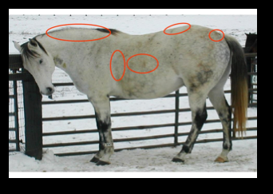

Insulin is produced by the pancreas and its principle function is to regulate and to control the blood sugar levels. In type 1 diabetes in humans, the pancreas is unable to produce normal levels of insulin, and as a result the blood sugar level rises. In type 2 diabetes, the action of insulin is blocked by these fat derived hormones. Consequently, in an attempt to control the blood sugar levels, the pancreas tries to compensate by producing even higher levels of insulin. This is called ‘Insulin dysregulation /resistance’. We now know that high circulating levels of insulin can directly cause laminitis. This condition is common in native breeds and most often occurs in younger horses and ponies.

We also recognise a very similar condition whereby some horses become ‘sugar intolerant’. In this instance they have normal resting levels of insulin, but these levels surge in response to relatively small amounts of dietary sugar (eg. Spring grass). These spikes in insulin levels can be sufficient to cause an attack of laminitis in certain individuals. This might explain why only one horse or pony from a group grazing on lush spring grass goes on to develop laminitis. It is not the sugar in the grass per se, but it’s his metabolic response to it.

We can test for this by taking a couple of blood samples. We currently recommend the Liphook Laboratory protocol for insulin resistance testing. You first must get a reasonably accurate estimate of your pony’s weight, -weigh tape? Then you purchase some ‘Karo Light’ from Amazon. You give 45mls of ‘Karo Light’ per 100 Kg, (in a small feed, -eg Hi Fi Lite, /by syringe directly into his mouth), (ie. a 500Kg horse will need 225mls of ‘Karo Light’). Then you blood test 60-90 minutes later. This test MUST be booked in advance at the clinic, (-so that we can have a vet available at the correct time). We usually recommend early mornings as the most convenient time all ‘round. Horses that react positively are at a high risk of developing laminitis (if they do not already suffer from it. There is now also a test for adiponectin levels. Adiponectin is produced by the fatty tissue and helps with regulation of the body’s response to insulin. EMS prone ponies have unusually low levels of this hormone and it can be used as a sensitivity test to check the susceptibility of an individual to developing laminitis.

Affected horses /ponies MUST lose all this dangerous fat. In non-laminitic horses this is best achieved by a combination of dieting and exercise. However, we cannot exercise horses /ponies currently suffering from laminitis. Therefore, the only way that these horses can lose weight is by restricting their calorie intake. It is imperative that we control their TOTAL calorific intake, this must include any grass consumed each day. This weight should be lost gradually; crash diets are a bad idea and can cause even more problems for affected horses. We would usually recommend that initially they are fed between 1.25% and 1.5% of their target weight daily (ie. A horse with target weight of 500Kg would be fed between 6.25Kg and 7.5Kg (dry weight). Soaking the hay for one hour in warm water (for up to 12 hours) reduces the amount of soluble sugars, but it may also reduce the mineral /vitamin content. We usually recommend that they are fed a small amount of a ration balancer to ensure that they get an adequate amount of essential amino acids and micronutrients. Please note that the amount of this balancer fed daily must also be included in his total daily intake calculation. As horses are adapted to eat little and often, these feeds must be divided into several feeds spread over the whole day. Double netting the hay, (or even suspending the net from the centre of the stable ceiling) helps pass the time and spreads the feed over a more prolonged period. Loosing this extra fat will usually in itself decrease the insulin resistance, reducing the laminitis risk. Once your horse reaches the target weight he MUST remain slim, with the use of regular exercise, restricted turnout, grazing muzzles etc. Regularly check and record his weight with a weigh tape. (You could clip an area on his withers to check that you are measuring in the same way each time).

Unfortunately there is no licensed drug treatment for EMS in horses. We find that Metformin®, a product used to treat type 2 diabetes in humans can be useful in helping manage this condition. This reduces sugar absorption from the gut (and possibly helps reduce insulin resistance). We currently recommend its use for the first 3-6 months. Recently a new class of drug, Sodium-glucose co-transporter 2 /SGLT2 drugs, (eg. Velagiliflozin, Canagliflozin, /Ertuglifozine etc), has become available. This class of drugs increases the secretion of glucose in the urine, consequently reducing the blood levels of both glucose and insulin. Some veterinarians (especially in the USA), occasionally use thyroid hormone extracts in an attempt to help resistant cases to lose weight. There have been reports that chromium and magnesium supplementation of the diet may also be helpful in this condition. It is very important to remember that these drugs /dietary supplements etc, remain an aid to reducing insulin resistance. They cannot replace the need to diet overweight horses and to keep them slim subsequently. Nutritional intake is impossible to control in horse at pasture and grazing muzzles can prove useful in some greedy ‘good doers’. Unfortunately, some horses still remain hyperinsulinaemic even after they have achieved an appropriate body weight /condition score. Increasingly we believe that all horses are better maintained on a fibre based diet. However, some competition horses have greater calorific requirements. These horses may need to be fed low sugar calorie dense feeds (eg. Non molasses soaked sugar beet, rice bran, vegetable oil), rather than a cereal (starch) based diet.

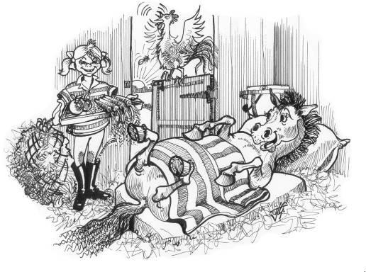



The Acorns Equine Clinic, Pleshey, Chelmsford, Essex. CM3 1HU
Telephone (01245) 231152, Fax: (01245) 231601
www.essexhorsevets.co.uk

