Equine Cushing’s Disease (/Equine PPID).

.
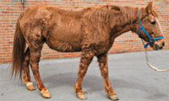
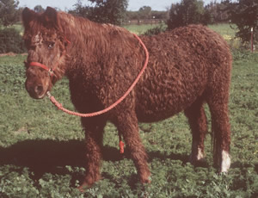

This disease has been described in many different species of animals, and is particularly common in older horses/ponies.
Clinical Signs
-Laminitis
-Increased risk of infections e.g. skin disease, lice, worms, dental disease
-Increased drinking and urination due to Diabetes
-Thick, long or curly coat taking longer to shed in springtime than normal
-Pot bellied appearance and swayback
-Weight loss or muscle wastage
-Depression
-Bulging of fat pads above the eyes (supraorbital fat pads)
-Infertility
-Increased sweating

Horses with Equine Cushing’s Disease can be hard to diagnose as they rarely show more than one clinical sign. As can be seen from the above list, many of the clinical signs can simply be dismissed as due to the normal aging process.

To understand what happens in Equine Cushing’s Disease we need to understand the normal processes involved.

The Normal Situation

The brain has a tiny endocrine gland (about the size of a pea) beneath it called the Pituitary Gland. The Pituitary Gland produces several different hormones including one called ACTH this acts on the Adrenal Glands (near the kidneys). These glands are in turn stimulated to produce Cortisol (a natural steroid). Cortisol has many functions including water regulation, sugar distribution and the fight-flight response, high levels of circulating cortisol can result in laminitis. Cortisol levels are also regulated by a chemical called Dopamine. Dopamine is produced by the Hypothalamus, another important area in the brain involved in many hormonal processes. When Dopamine is produced by the Hypothalamus it reduces the amount of ACTH (and other small peptides) produced by the Pituitary Gland and consequently the amount of Cortisol produced by the Adrenal Glands.
The Normal Situation (simplified version)

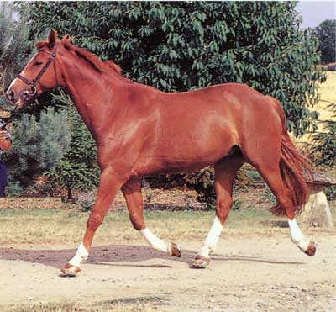
BRAIN
PITUITARY
GLAND
KIDNEYSSS
ADRENAL GLANDS
ACTH
CORTISOL
NEGATIVE FEEDBACK
HYPOTHALAMUS
DOPAMINE
(reduces ACTH production)
ACTH
Equine Cushings Disease
Due to reduced production of Dopamine by the Hypothalamus there is a dysfunction of the Pituitary Gland with an overproduction of ACTH (and the other peptides) resulting in increased production of Cortisol (adrenal gland) and Insulin (pancreas), this leads to the classic symptoms (see above).

Equine Cushings Disease (simplified version)
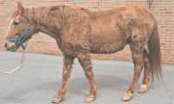
KIDNEYS
BRAIN
PITUITARY GLAND
ACTH
LAMINITIS
INFECTIONS
HYPOTHALAMUS
DOPAMINE
DEPRESSION
SWEATING
CORTISOL
ADRENAL
GLANDS
NEGATIVE FEEDBACK
THICK
COAT
INCREASE
DRINKING + URINATION
Diagnosis
There are several tests available for diagnosing Equine Cushing’s Disease. There are dynamic and static tests. At the Acorns Equine Clinic, we recommend the use of a static test. A single blood sample is taken to test the ACTH levels. However if the results are not clear cut it may be necessary to use a dynamic test.
The most commonly used dynamic test is the Dexamethasone Suppression Test. Here an initial blood test is taken and a synthetic steroid is then injected into the horse. The change in Cortisol levels produced is recorded (therefore testing the negative feedback pathway). This requires at least two visits and blood samples and has the added risk of actually causing laminitis due to the steroid administered.

Treatment
Treatment includes management changes and medication.

- Pergolide
This is the only product currently licensed to treat Cushings disease in equidae (Pergolide /Peroquin). This drug increases the amount of Dopamine produced by the Hypothalamus gland. It therefore reduces the amount of ACTH and peptides produced by the Pituitary Gland and hence the amount of Cortisol /insulin produced. Ponies are usually started on 1mg per day and horses on 1-2mg per day. The response is checked 4 weeks later with a follow up blood sample. The dose may then be altered to suit individual situations and could need to be increased up to 5mg/day. Occasionally a short lived drop in appetite may be observed when Pergolide is first given, this normally resolves within a few days and the appetite will return to normal.
- Cyproheptadine
Another drug that has been used for treatment of Equine Cushing’s Disease is cyproheptadine (Periactin). This has been shown to be effective in a more limited amount of cases.
- Monkspepper or Chasteberry (Vitex agnus castus)
This herbal supplement is also currently being trialled and full results are not yet available, however anecdotal evidence seems to suggest an improvement in coat condition and general demeanour.

Management

Diet is very important for the horse with Equine Cushing’s Disease and keeping them at the correct bodily condition and weight can be hard. Advice can be obtained from qualified equine nutritionists such as at Bailey’s Horse Feeds (01371- 850247). Management changes include dietary control in overweight ponies (/horses). Feeding a high fibre diet, (soaking hay for up to 12 hours in some individual circumstances). Wearing grass muzzles and regular exercise will also be helpful in controlling weight.

As horses and ponies with Equine Cushing’s Disease have a greater risk of developing complications regular veterinary check-ups are vital. Dental check ups are also recommended at least every 6 months to prevent dental disease. Regular foot care and trimming is also important especially where laminitis is a complicating factor. We believe that periodic ongoing blood tests to check that affected horses remain on the correct dose of Pergolide is important.



The Acorns Equine Clinic, Pleshey, Chelmsford Essex CM3 1HU.
(01245) 231152, Fax. (01245) 231601.
www.essexhorsevets.co.uk

