Coughing horses (Equine Asthma /lower airway disease).

Lower airway disease is a major cause of poor performance in horses and is characterised by the presence of a cough. It is typically caused by either RAO or IAD.

RAO stands for Recurrent Airway Obstruction (formerly called Chronic obstructive pulmonary disease /COPD) and is primarily caused by an allergic reaction, (usually to the fungal spores commonly found in both hay and straw). This is a very common condition in horses over five years old. It occurs mainly during the winter months in stabled horses but may occur all year ‘round. Affected horses cough either spontaneously or in association with exercise and typically have signs of laboured breathing at rest.
IAD stands for Inflammatory Airway Disease, this typically occurs in younger horses and may have an infectious (viral?) underlying cause. Affected horses often have normal breathing at rest, they may only cough when exercised and usually suffer from poor /loss of performance. IAD is a milder condition which if not managed properly may lead to RAO

There is another condition similar to RAO called SPAPD, (Summer Pasture Associated Pulmonary Disease) which is believed to be an allergy to pollen spores and classically occurs in pasture kept horses during the summer months. All of these conditions result in spasm and thickening of the airways, excessive mucous production and a ‘heaveline’. The symptoms include reduced tolerance to exercise, coughing and difficulty in and or laboured breathing. Interestingly horses have a very poor cough reflex so when they start to cough it is likely that the lung lesions are already well advanced. It is thought that as many as one in six horses in the UK suffer from lower airway disease to a greater or lesser degree.

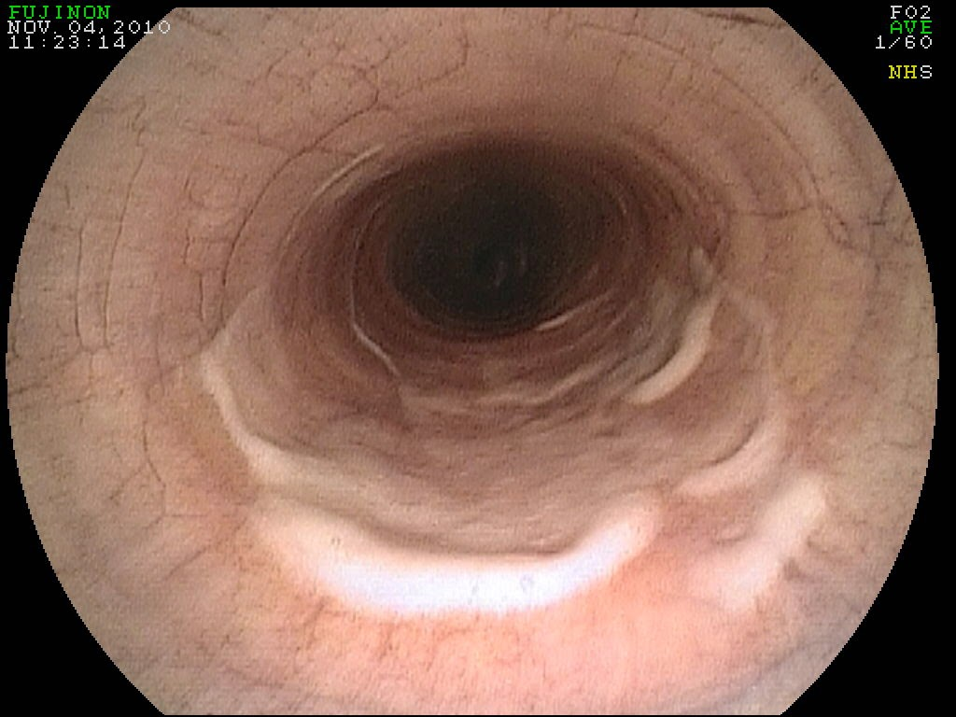

View of the trachea (windpipe), showing mucus /pus.

Unfortunately, there is currently no cure for these conditions but they can usually be managed so that most horses continue to compete successfully. Drugs can only alleviate the symptoms of lower airway disease. Managing these conditions consists basically of removing your horse from all possible allergens and is fundamental to controlling them. Done properly this can often result in your horse being able to live and compete normally. It is the attention to detail that determines the overall success of any management changes. We advise that you turn your horse out as much as possible. If stabling is essential we recommend that he is best kept in a well ventilated building and you bed him on shredded paper /cardboard, dust extracted shavings or Hempcore. Please remember that in barns these measures will be much more effective if applied to the building as a whole. Remove wet bedding as frequently as possible. Ideally, he should be fed from the ground to promote drainage from the lungs. He should not be in the stable while it is being mucked out and ideally, he should be groomed in the open air. Do not exercise in dusty schools etc. Deep litter bedding systems are a very poor choice for these horses. In exceptional cases we advise that some horses with RAO live outside and have access to a field shelter. Conversely with SPAPD we advise that you stable your horse, at least during the day, to keep him away as far as possible from the pollen.

Feed hayledge /good quality hay, (soaking it if necessary). DIY steaming hay will only help mildly affected horses. Commercial steamers are in our opinion very useful, but often prove to be expensive for many owners. To soak hay effectively we recommend that you immerse it in water for about 20 minutes before feeding it. This does three things to the hay, firstly it washes it, (-look at the colour of the water drained off subsequently), secondly it sticks the spores to the fibres and lastly (and probably leastly) the individual spores absorb water and swell up, making it difficult for them to get down to the critical levels of the lung to cause the reaction in the first place.

Rubber stable mats can be very useful in helping to manage these conditions. You should balance the initial expense in purchasing them as against the ongoing cost of alternative bedding. It is also very important that the floor drains well, otherwise urine collects beneath them giving off ammonia which is irritant to the lungs and would aggravate these conditions. You might need to consider using Biofresh (from Biotal) this is a microbial product, which contains enzymes to block ammonia production. Where rubber mats are used we recommend that you just have a very thin layer of shavings to reduce urine splashing and to soak it up subsequently. One major disadvantage of rubber matting however is that if horses (especially youngsters) lie down on them then you can considerably reduce the life expectancy of their rugs.

When we are asked to medically treat coughing horses we advise our clients that in the absence of the above management changes, drugs alone are unlikely to be able cure /successfully manage this condition. Where we have adequate air hygiene management and in the absence of a bacterial infection, we would often put the horse on a course of corticosteroids (dexadresson /prednisolone). These can initially be injected, or fed as tablets /powder, and in more chronic cases inhaled as a powdered mist (just as in human asthmatics), but in this case through a special mask /’baby haler’ (spacer device). The aim is to get maximal drug levels into the lungs without the risk of the systemic side effects we sometimes associate with corticosteroid use (e.g. laminitis). Corticosteroids are often combined with bronchodilators eg. Clenbuterol (‘Ventipulmen’) and/or mucolytics (eg. ‘Sputolosin’) which are mixed in with his feed. These are all prescription drugs, so by law that they can only be used after a clinical examination and a diagnosis by a veterinary surgeon.

In difficult cases we sometimes use ipratropium bromide (an atropine like drug) to help open the airways, this is also given via a face mask (/spacer device). NSAIDS (eg. Bute) are ineffective in treating lower airway disease.

There is a new product which has only very recently arrived on the market. This is ciclesonide, (which is reported to be ten times more potent than dexadresson). This is delivered as a fine mist via a specially developed easy to use ‘Aservo Equihaler’.

Where clients have access to a nebuliser they often find that nebulised dexadresson is a very cost effective treatment. However, they must first weight the substantial up-front purchase cost against the benefits. There is another drug Chromoglycate (formerly called ‘Chromovet’), which prevents the release of histamine (the cause of allergic reactions) in the lungs and thus theoretically will prevent the spasm and mucous occurring in the first place. This drug is a liquid, which must be inhaled as a mist so in addition to the facemask you need a nebuliser to convert it into a mist prior to inhalation. In theory this should be a very useful drug, however in our experience it only helps a minority of horses (SPAPD?). Some people try various homeopathic remedies with various degrees of success. Finally, it might be possible in certain circumstances to take a blood test (RAST test) and try to work out exactly what your horse is allergic to. Then it may be possible to make a vaccine for him, this is still fairly new technology so it might be worth discussing this with the attending vet. If a horse shows little improvement after a course of medical treatment, especially where the air hygiene seems good, we recommend that we endoscopically examine him and take a tracheal wash from his lungs. This can confirm that the air hygiene management is adequate and look for any evidence of bacterial infection. In this instance we would put him on a course of the appropriate antibiotics and rescope him later to confirm that it has worked. As a general rule we recommend that all horses are rechecked once a course of treatment has been completed, because as stated above absence of coughing is not a reliable sign that an individual horse has made a complete recovery. They may still be suffering from a sub-clinical condition which could increase the chances of recurrence and still affect his ability to compete /work successfully (eg. IAD).

Non-prescription herbal drugs that can be tried in MILD cases include Balsamic Control, /Respamin etc. Additionally, you can try feeding the food supplement ‘Winergy Ventillate’, this tries to mop up the free radicles, which occur in inflammation.

Each horse is treated as an individual and so the exact details of your horse’s treatment will probably vary according to his specific needs. In all instances however we will be happy to discuss with you should you have any worries or specific queries you would like addressed.

TOP TIP

To soak hay, we advise that you purchase a water butt barrel from a garden centre and cut off the top half, retaining the lower half with its tap. Place the hay in sections into the barrel, fill with water and soak for 20mins, then open the tap and allow the water to drain away. Drag the barrel into the stable and allow your horse to his hay from it. This will ensure that the hay does not dry out wetting the bed in the process. Also by feeding from the ground you will promote drainage from the lungs.



