Control of Pinworms (Oxyuris Equi).

The mature females live in the posterior large colon and rectum, they crawl out of the anus and stick their eggs to the perineum of infected horses. This causes intense itching, producing similar signs to sweet itch, (except that the mane is obviously NOT affected and that in this case they tend to rub the underneath of the tail and the buttocks). The females are usually about 2-3 inches long and look not too dissimilar to bean sprouts, -they may be found by the anal ring /in the droppings. The eggs then either eventually fall onto the ground or are rubbed onto fences etc. Horses become infected by eating the eggs (eg. licking the timber on the fence /wall etc). The life cycle is usually about five months.

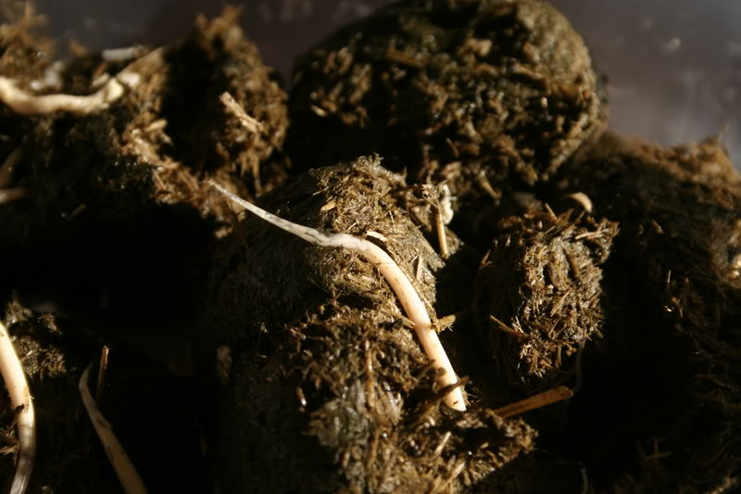

- Infection is diagnosed by taking a cellotape smear from the perineum and finding the eggs when it is examined under a microscope.
- According to the standard veterinary parasitology texts, pin worms are controlled by routine anthelmintic treatments. However in our experience this is often not the case.
- We currently recommend treatment with a five day course of Panacur Equine guard every month for six months.
- Other treatments we have used with some success include. Double doses pyrantel orally, TOGETHER with a syringe of pyrantel into the rectum, and around the anal ring. (We prefer to sedate horses for this). Five day course of Panacur Equine Guard, followed by a triple dose of oral ivermectin, together with ivermectin washes TWICE daily into and around the anal ring, the underside of the tail head and the perineum for at least four weeks.
- All affected horses (ie. All known ‘Tail rubbers’) must be similarly treated.

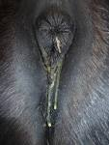

- Hopefully these treatments will eliminate the adult females, they are often seen in the droppings subsequently and the affected horses stop itching their tails. However we MUST now try to eliminate the eggs in the environment to prevent reinfection and recurrence of the clinical signs 4-5 months later.
- Remove all bedding, the stables MUST be steam cleaned with a strong disinfectant (eg. Virkon /Trigene), ideally if they are of timber construction they should also be creosoted subsequently. Anything that he could have itched /rubbed his tail on MUST also be similarly treated, (eg. Doors, window ledges, fences etc).
- Do not share dock sponges between horses or especially use them to wash his mouth, -preferably use disposable baby bottom wipes. Wear disposable gloves each time you clean /treat the dock region of affected horses.
- Thoroughly disinfect tack, rugs, grooming kits etc, -anything that could directly or indirectly transfer eggs from one horse’s perineum to another.
- REMEMBER THAT IT IS ATTENTION TO DETAIL THAT WILL DETERMINE THE SUCCSESS OR FAILURE OF THIS REGIEME. You will know if it has failed as he will restart rubbing his tail in a matter of months.



The Acorns Equine Clinic, Pleshey, CHELMSFORD, Essex. CM3 1HU.
Telephone (01245 231152), Fax (01245) 231601.
Essexhorsevets.co.uk.

