Care of the pregnant /foaling mare.

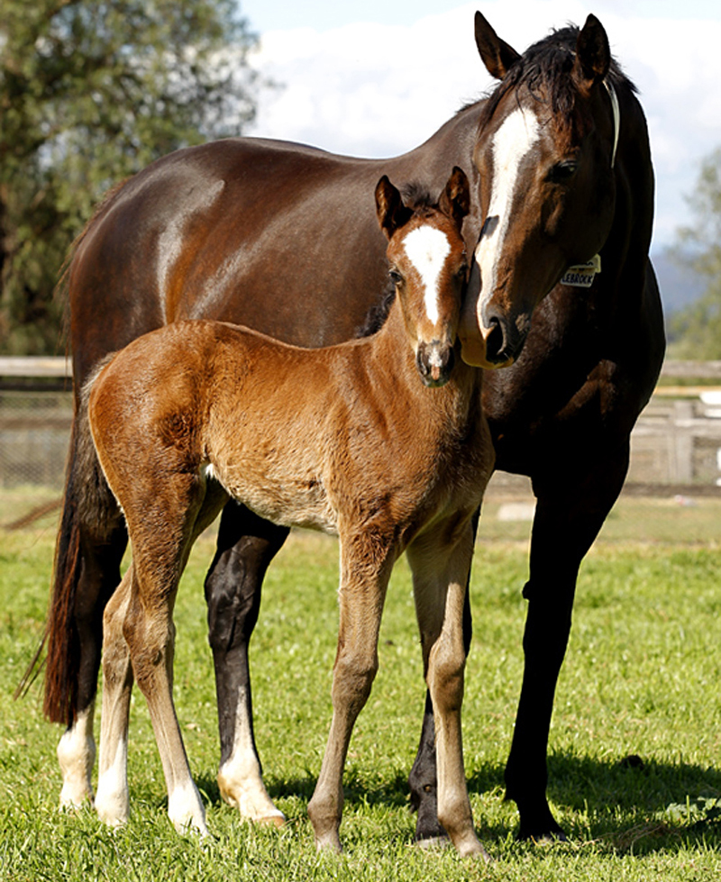

Following covering the first pregnancy ultrasound scan is usually performed between 14-16 days. This is an important exam because it is the best time to correct a twin pregnancy and also allows you to begin planning rebreeding if she is not pregnant.
We recommend that another ultrasound scan is performed between days 24-25 of pregnancy to find the embryonic heartbeat (and again to check for twins). The next important scan takes place at around 35-42 days. If the mare has lost the embryo before this time she can usually be re-bred successfully; but if she is pregnant at 35 days and then aborts, she is not fertile for another 3-4 months due to formation of the endometrial cups in the uterus. These structures, which come from the embryo and implant into the uterine wall, do not die even if the pregnancy aborts until around 120 days after mating. Throughout this time they produce a hormone (ECG), this hormone prevents the mare coming back into season. This usually means that the breeding season is over for that mare.
The presence of ECG in a blood sample can also be used as a pregnancy test. However you must remember that its presence just means that she was pregnant at 45 days (see above), she could have lost it subsequently. We can blood test looking for Oestrone Sulphate in mares over 120 days pregnant. This hormone is produced by the foal from > 120 days. Its presence indicates the presence of a live foal at the time of testing.
A further exam to confirm that the mare is still pregnant is usually performed in the autumn (for TB’s this is usually the end of September). On average, a young mare pregnant at 14-16 days has approximately a 6% chance of losing her embryo by day 40, and an 8% chance of aborting after day 40. The expected loss rate increases progressively with age and for a 20 year-old mare losses are 21% at day 40, and 15% after day 40.

Nutrition
To ensure maximum fertility a mare should have a moderate body condition score (2.5-3.0 out of 5) when she is covered. The foal does most of its growing towards the end of gestation with 2/3 of this coming in the last 3 months. During the first 8 months of pregnancy the mares' nutrition requirements are no different to those before she conceived. In the last trimester, the mare’s requirements for protein, calcium, sugars and phosphorus increase faster than the need for energy, and may require supplementation. Free access to high quality grass, hay or alfalfa, will meet energy requirements and usually those for protein (which have gone from 8% earlier in pregnancy up to 11-12% now). However, neither of these forages will meet her increased need for phosphorus and grass forages will also be too low in calcium. To correct this, mares should receive a good quality mineral vitamin mix. For example, copper, zinc, manganese, and iron must be stored in the foetal liver. Research indicates that when mares were not supplemented with copper in the last trimester, the foals were not as sound compared to foals born to copper supplemented mares. Feeding supplemental copper to the nursing foals did not correct the problems. Supplementation of natural vitamin E in the 30 days before foaling can also increase the passive transfer of antibodies to the foal.
Once lactation starts, the mare's energy and protein needs increase further. Very good quality forage with a mineral supplement can meet these needs, but most mares should receive a grain/protein mix in addition. This is also the time most mares are re-bred, and fertility is best when the mare is not losing condition. After 3 months of lactation, a mare's milk production is usually declining, start slowly decreasing her grain before weaning to help dry the mare up.

Exercise
Provided you have been given no specific advice against it (usually in cases of lameness or injury) most mares benefit from exercise during pregnancy. Many mares have been used for rigorous athletic competition (including racing and jumping) up to 5 months with no problems. Light hacking could continue until the start of the last month of pregnancy in some cases, though you may need to find a saddle that matches her new shape. We recommend that you stop riding your mare from the start of the last trimester. Mares that aren't ridden benefit from as much turnout as possible, preferable a minimum of 6 hours a day when conditions allow.

Worming and vaccinations
Internal parasite control relies on a combination of pasture management, manure disposal and strategic use of wormers. Most modern wormers are safe for use in pregnant mares, but always check the label first. Mares generally remain on the same worm control schedule as other mature horses on the farm. We recommend worm egg counts every three months, worming any horse with a worm egg count over 200 eggs per gram. It is now commonly recommended that mares also be given a dose of ivermectin on the day of birth to help prevent transmission of worms to the foal.
Vaccination of the broodmare has 3 aims; protect the mare from disease, to prevent abortion, and protect the foal by passive transfer of immunity through colostrum. It is recommended that vaccines are not given to mares in the first 60 days of pregnancy. Ideally mares will have completed their primary course of vaccination before becoming pregnant. To ensure maximal protection of the new-born foal, we recommend that pregnant mares are vaccinated for Flu and tetanus in the last 3-6 weeks of pregnancy.
Additionally pregnant mares can be vaccinated against Equine Herpes virus (EHV1 and 4). This disease can cause abortion. The vaccine is given at the 5th 7th and 9th month of gestation. In some stud farms where Rota virus infection in foals is a problem, mares can be vaccinated against this disease whilst pregnant, (8th, 9th and 10th month). Your vet can advise you on which of these vaccinations are likely to be beneficial in your situation and when they are best administered.

Signs of approaching foaling
The length of a normal pregnancy is usually 335-342 days, but occasionally can range from as little as 315 to over 400 days. About a month before foaling many mares start to develop oedema low down on their abdomen. At about the same time the udder slowly starts to enlarge and this development accelerates at 2 weeks before term. During this early development the udder remains firm. A few days before foaling, the udder gradually softens and fills with fluid which slowly changes in appearance from watery, to thick (honey like) colostrum. The colostrum is generally present 1-2 days before birth.
Softening of the pelvic ligaments is progressing during this stage and the mare's tail head may appear more elevated. Wicks of dried mammary secretion (waxing) usually appear about 1 day before birth and in the last few hours some mares will drip milk.

Preparation for foaling
The mare can foal in a grassy paddock or large well-bedded stable. The stable should have been stripped out, disinfected and re-bedded. Clean straw is generally preferred as there is less chance the foal will breathe it in. Maiden mares can be accustomed to having their udder handled over the last week of two prior to foaling. She can be fitted with a ‘foaling alarm’. This is a harness which when fitted alerts you to the fact that she is sweating. Remember that some mares don’t sweat and therefore won’t necessarily trigger this alarm. Many people now fit a video camera linked to either their laptop or TV set to keep a close but discrete eye on their mare.
Things you want to have available are:
- Phone and numbers for your vet and a close neighbour who is experienced at foaling
- A clock or watch, notepad and pencil so you can keep track of the timing (estimating time accurately during and after a foaling can be tricky)
- Old clean towels for drying off the foal
- Disinfectant and small cup to hold it in while you dip the navel (/’blue spray’)
- Bucket, soap and warm water for clean-up
- Strong bucket for the placenta
- Plastic or rubber gloves to keep your hands clean

Normal foaling
Foaling is usually divided into 3 stages.
Stage 1. the cervix gradually relaxes and the uterus starts to contract, pushing the placenta, foal and fluids against the cervix to help it dilate. This stage lasts 1-6 hours and sometimes goes unnoticed. Mares may appear mildly colicky, look at their flank, stretch out, urinate and pass manure frequently and lie down repeatedly. This may coincide with dripping of milk. At the end of this stage the mare's water breaks.
Stage 2 is delivery of the foal. Usually this occurs with the mare lying on her side, though she may stand and lie down again several times during the process, especially before the head is delivered. The mare actively strains, usually in series of 3 or 4 followed by a short rest. Within about 10 minutes of her water breaking, a whitish translucent fluid filled balloon (the amnion) should appear. Next, encased in this membrane, a foot appears. The soles of the feet should point to the mare's feet (i.e. the foal is the same way up as the mare). It is normal for the legs to protrude further as the mare strains and then slide back when she relaxes. This gradual movement is important for proper dilation of the birth canal. Resist the urge to immediately grab the legs and pull when they appear as this can result is damage to the cervix and vagina that may affect the future fertility of the mare.
The nose should appear next, lying on top of the legs. Passage of the head often takes a little longer in maiden mares as the vagina stretches over the poll. Allow time for dilation to occur. At this point the widest part of the foal, its chest, is entering the birth canal and the mare often strains harder. It is important that the feet do remain one in front of the other rather than even as this configuration minimizes the width of the shoulders, making them much easier for the mare to pass. Once the chest is out the rest of the foal usually passes easily, and the mare often stops straining. Unless the mare is kicking at the foal they should be left alone. The mare generally rolls onto her chest and stands within 15 minutes and the umbilical cord breaks 1-2 inches from the foal’s abdomen. With normal, vigorous foals the amnion or water bag usually ruptures by the time the chest is passing so the foal can breathe. If it doesn't it should be torn open and cleared away from the head.
Stage -3 is the passage of the placenta which usually occurs within 1 hour after the foal is born. The mare may be slightly colicky while this is occurring. The placenta should be saved so it can be checked for completeness and for any signs of infection.

When to call for help - signs of a problem
From the time the water breaks to completed delivery usually takes about 20 minutes, though occasionally may be extended to 1 hour. Experience is the best guide to potential problems, but a few rules of thumb are presented below. In general, any time reasonable progress is not being made, there could be a problem and it is better to call for help rather than wait and see. Time is of the essence if we are to get a normal foal. Call the Vet immediately if:
- the amnion or a foot has not appeared in about 10 minutes after the water breaks
- only one foot appears and isn't followed by the other
- the feet are upside down
- the nose appears first
- one or both feet are over the top of the head

Finally!

The foal usually gets up within an hour and sucks shortly afterwards. In our experience some foals (very often colts) can find it very difficult to ‘latch on’ and suck. This scenario requires particular patience especially as it is often very late at night. Some owners milk the mare and bottle feed the foal. We recommend that you stay with the mare and foal to ensure that you see it suck properly and that they are properly bonded. Some maiden mares may be extremely ‘foal proud’. They may not let it suck. In this instance hold her head, patting /stroking her to relax her. It is very important that the foal gets colostrum. A foal has a fully functional immune system, but as he has developed in a sterile environment, he has no antibodies of his own. He can of course make them, but this process can take a few weeks. To protect him in the interim the dam provides colostrum, this is rich in all her own antibodies and will protect him until he can produce his own. The foal has a period of about 12 hours (on average) when he can absorb these antibodies. If the mare has not passed the placenta in about 3-4 hours, then tie it carefully with string to about the level of the hocks.

Call the vet out in the morning, to check the mare for any tears, haemorrhage, they can check the foal over to ensure that it is healthy, give it a tetanus antitoxin injection, take a blood test and check it’s IGG (antibody) levels. This ensures that the foal has adequate protection against infection. Finally they can check that the mare has completely passed the placenta.

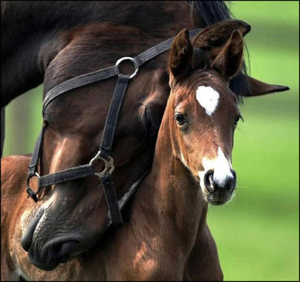

The foal should be wormed once a month for his first six months and he should start his course of flu /tetanus vaccinations from between 5-6 months of age, (depending on manufacturer’s instructions).



The Acorns Equine Clinic, Pleshey, CHELMSFORD, Essex. CM3 1HU.
Telephone (01245 231152), Fax (01245) 231601.
Esseshorsevets.co.uk.

