Breeding from mares.

Breeding a foal from a much loved mare is potentially one of the most rewarding things that we can ever do as horse owners. However it can be an emotional roller coaster ride as well as an expensive process and should never be undertaken lightly. There is an old saying in Ireland that ‘fools breed horses for wiser (traditionally English) men to buy subsequently’. There is an element of truth in this, in that mare owners need to be very critical of their potential blood lines. Just because your mare is lame or injured is not a good reason to breed from her. Do you really want to perpetuate her conformational faults and end up with pretty much the same problems further down the line? As a breeder you should always try ‘to the breed the best with the best and to hope for the best’. We always advise that you should decide in advance just what type of horse you are trying to breed. Be critical of your mare’s conformation and try to choose a stallion that compliments her. In this respect the breeder has to hope that the foal turns out alright, whereas the buyer gets to see just what he is buying, so that he can have no cause for complaint if he subsequently doesn’t turn out to be a champion (see above).

In general terms one could consider that in some respects there is no such thing as a subfertile mare. Unlike a bitch who could have three puppies instead of thirteen, a mare either is pregnant or she is not. Although they do not have a menopause, younger mares are usually more fertile than older ones. So if you intend to breed from your mare, we recommend that you do so sooner rather than later.

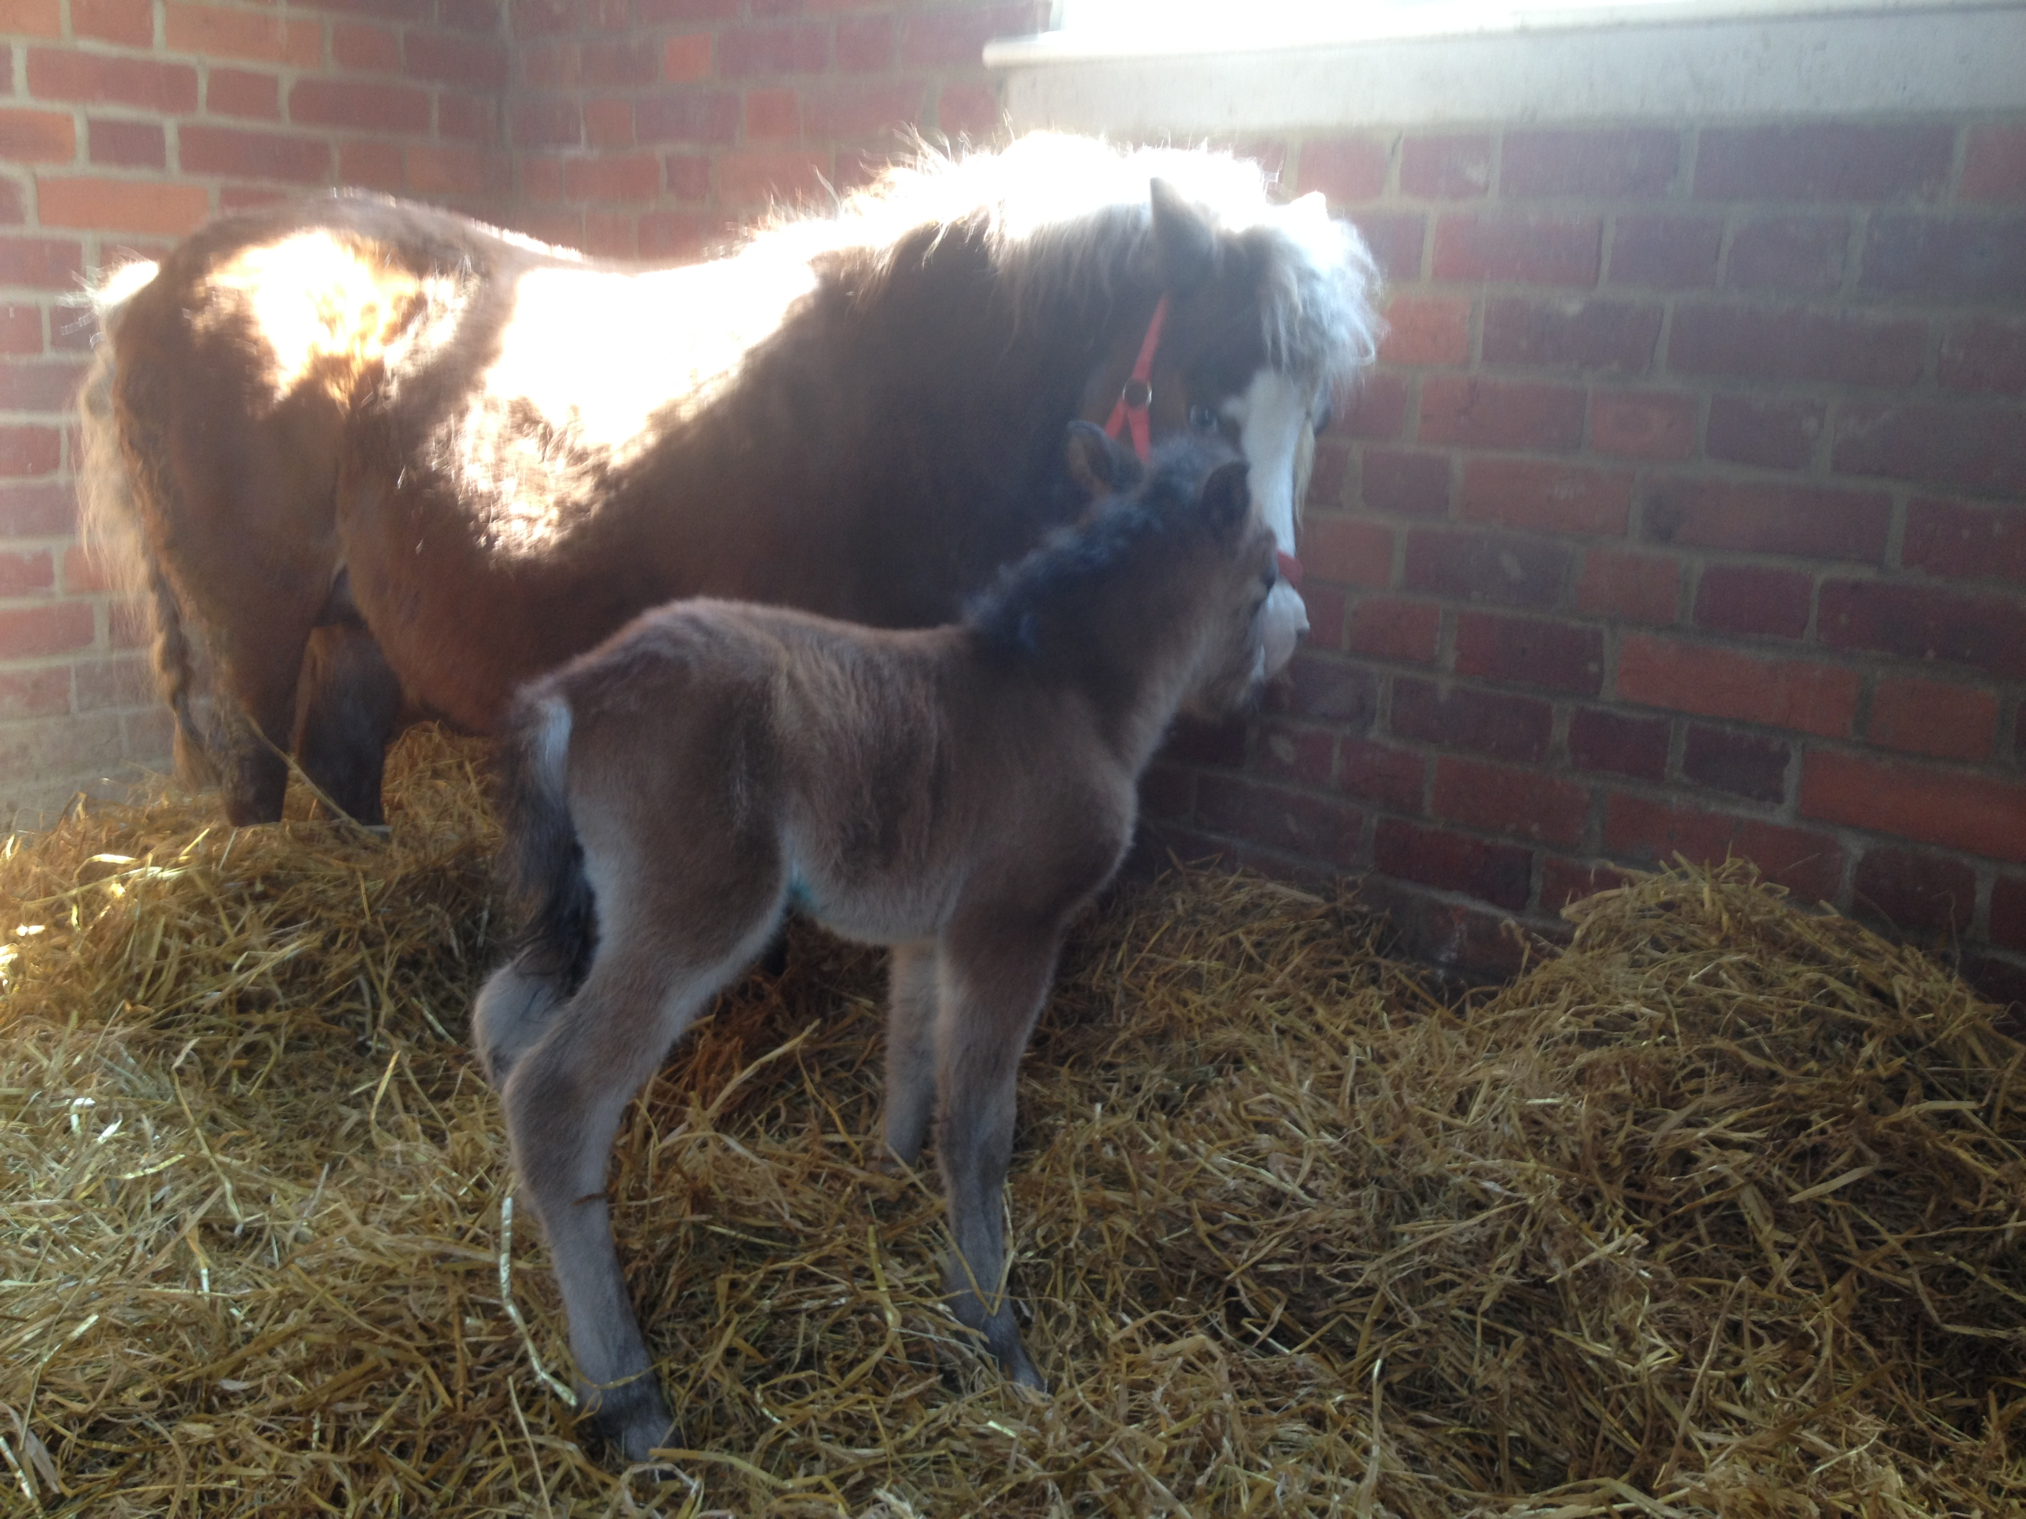

Mares can either be covered naturally or by artificial insemination (AI). There are three types of AI, (fresh semen, chilled semen or frozen semen). Under ideal circumstances a mare is usually mated within twelve hours of ovulation (preferably before ovulation). With natural coverings, the mare needs to go to stud to visit the stallion. She can board there until she is scanned in foal or she can ‘walk in’, (ie. just go to be covered and come home immediately afterwards). In either event you, as an owner are limited in your choice of stallion by the distance you are willing to transport your mare. Additionally there is always a risk that the stallion might physically injure your mare whilst she is being covered. With AI the mare can either go to a commercial stud or your local veterinary clinic. You have a much wider choice of stallions in that the semen can come from much greater distance than you might have been willing to transport your mare. She usually boards at the stud /clinic and remains there until she has been scanned to have ovulated (‘gone off’). There is little risk of physical damage to your mare with this technique. Fertility rates vary between individual studs and clinics, but as a general rule of thumb, natural service has the highest rates of fertility, (followed by fresh semen, the by chilled semen and lastly by frozen semen). There is often little difference in the overall financial cost of natural service (boarding at the stud) or AI (boarding at the vet clinic). The stud fee (cost of the stallion) is usually the same with either technique. You will need to allow for vets fees (swabs, blood tests, ultrasound scans etc). Individual studs differ in their exact pre-breeding requirements, so please check with them in advance. Some studs and veterinary clinics may quote for an ‘inclusive package’ -so it may be worth asking for details.

Depending on the breed (/individual), mares will often reach puberty from three years onwards. They are seasonally polyoestrus, (ie. they cycle during the spring and summer months). Their reproductive cycle averages between 21-23 days, of which they are in oestrus (‘in season’) for between 5-7 days. They ovulate two days BEFORE they ‘go off’. They are pregnant for about eleven months (335 days). We recommend that you have your mare physically examined by your vet before sending her to stud. They can also take any pre-breeding swabs or blood tests required by the stud at the same time. The Horseracing Levy Board publishes a booklet detailing current best practice regarding pre-breeding swabs and blood tests each year. We prefer to recommend studs that adhere to this code of practice. Please remember that these swabs can take 7-10 days before we can get the results back from the labs subsequently.

Non thoroughbred mares would ideally foal down when the sun is shining and grass is plentiful (eg. April –June /July). So we would aim to mate her eleven months before this period. Overweight mares often have poor fertility. Ideally she will be in ‘light condition’ and be gaining weight when mated. In the absence of a teaser stallion (/a randy gelding), it can often be difficult to know when your mare has come ‘into season’. We can get around this problem by feeding the mare a 10 day course of the hormone Regumate. We recommend that she starts this on a Wednesday, this means that she will finish the course on a Friday, (when she is injected with a prostaglandin). Most mares will come ‘into season’ in 2-3 days subsequently. She can be booked to go the either the clinic (or the stud) for the following Monday morning. She could be swabbed (the check for uterine infections) and would be scanned daily (or twice daily if required) to monitor the size of the growing egg and estimate the ideal date for insemination /mating. This information can be updated on a daily basis gives the stud plenty of time to arrange collection of the semen. Please note that we have experienced some difficulty in the past in arranging deliveries over weekends (especially over bank holiday weekends). Once the mare is successfully inseminated, she would be scanned to confirm that she has ovulated. You now need to cross your fingers and wait for the subsequent pregnancy scans. To maximise your chances of getting a successful pregnancy, we recommend that you prepare yourself to present your mare for three cycles. Most normally fertile mares usually have conceived in this time period.

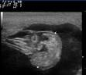

Once your mare has been covered she needs to be scanned to establish if that she has a single pregnancy. We usually recommend three scans (the first between 16-18 days, the next between 24-28 days and finally again at between 40-45 days). This significantly reduces the chance of your mare carrying twins. It is important to remember that no test is ever 100% effective. It is unusual for a mare to lose a foal after implantation of a single foetus (about 45 days). Once you have successfully passed this milestone, you now need to discuss with your vet the ongoing management (vaccinations etc) that are appropriate for your individual circumstances. Please also refer to our care of the pregnant /foaling mares factsheet (available form this website).



The Acorns Equine Clinic, Pleshey, CHELMSFORD, Essex. CM3 1HU.
Telephone (01245 231152), Fax (01245) 231601.
Esseshorsevets.co.uk.

