.

Azoturia

(Also known as ‘setfast’, ‘exertional myopathy’, ‘rhabdomyolisis’, ‘tying up’, ‘Monday morning disease’ etc).

Acute or sporadic azoturia is characterised by severe muscle cramping which results in sudden onset lameness and is usually associated with exercise. The underlying cause is not properly understood and is probably multifactorial. Many causes have been proposed including, high starch diets, stress, abnormal tissue calcium levels, vitamin E /selenium deficiency, hypothyroidism, viral infections (eg. EHV) etc. All breeds may be affected, females appear to be more likely to suffer from this condition compared to males. It can also be induced by excessively intense exercise in unfit horses, dehydration or electrolyte imbalances.

Recurrent azoturia could be associated with abnormal storage of polysaccharides (sugars) within muscle cells (polysaccharide storage myopathy /PSSM). This commonly affects quarter horses and draft breeds, but most if not all breeds can be affected. This is believed to be caused by a recessive gene.

Atypical Myoglobinuria is a similar condition which occurs sporadically (commonly in the autumn and often after a period of inclemental weather) and is not necessarily associated with exercise. Affected horses show sudden onset stiffness /weakness, which rapidly progresses to recumbency and often death. Single cases can occur, but it is more common for two or three cases to occur on the same premises over a period of several days. Recent evidence suggests an association between this condition and maple and sycamore trees, (possibly due to a mycotoxin found on these trees?). Treatment for this condition is often unrewarding and is symptomatic at present.

Symptoms:

Are usually associated with exercise. They vary from mild stiffness in the hindlimbs through to sweating, reluctance to move and possibly even recumbency. The affected muscles (usually the gluteals) are hard, painful and hot to touch. Affected horses will often pass muscle cell debris in their urine discolouring it (from dark yellow to amber and through to black). The symptoms may occasionally be confused with laminitis or colic.

Diagnosis and treatment:
If you suspect that your horse is suffering from an attack of azoturia, stop exercise immediately and get him back into his stable. Get a friend to collect him in a low loading trailer if necessary. Call the vet. They will confirm the diagnosis with blood samples. Depending on the individual circumstances treatment usually consists of non steroidals (bute), and depending on the individual circumstances may include mild sedation (eg. ACP) or fluids. The vet will advise on the duration and type of rest for the individual horse depending on the severity of the attack. The vet will also advise when affected horses can safely be gradually returned to work. This is usually on the basis of follow up blood samples.

Management:

Ensure that your horse’s diet is providing him with the right amounts of energy, protein, vitamins and minerals /electrolytes for the job you are asking him to do. In the first instance we recommend that he is fed a low starch high fat diet (ie. Cubes rather than mixes). A pony being hacked out at weekends should not be fed the same diet as a racehorse in full work. On ‘easy’ days, reduce the amount of feed you give your horse to reflect the reduction in exercise. If possible, ensure your horse gets some exercise every day, even if this is being turned out or hand walking.

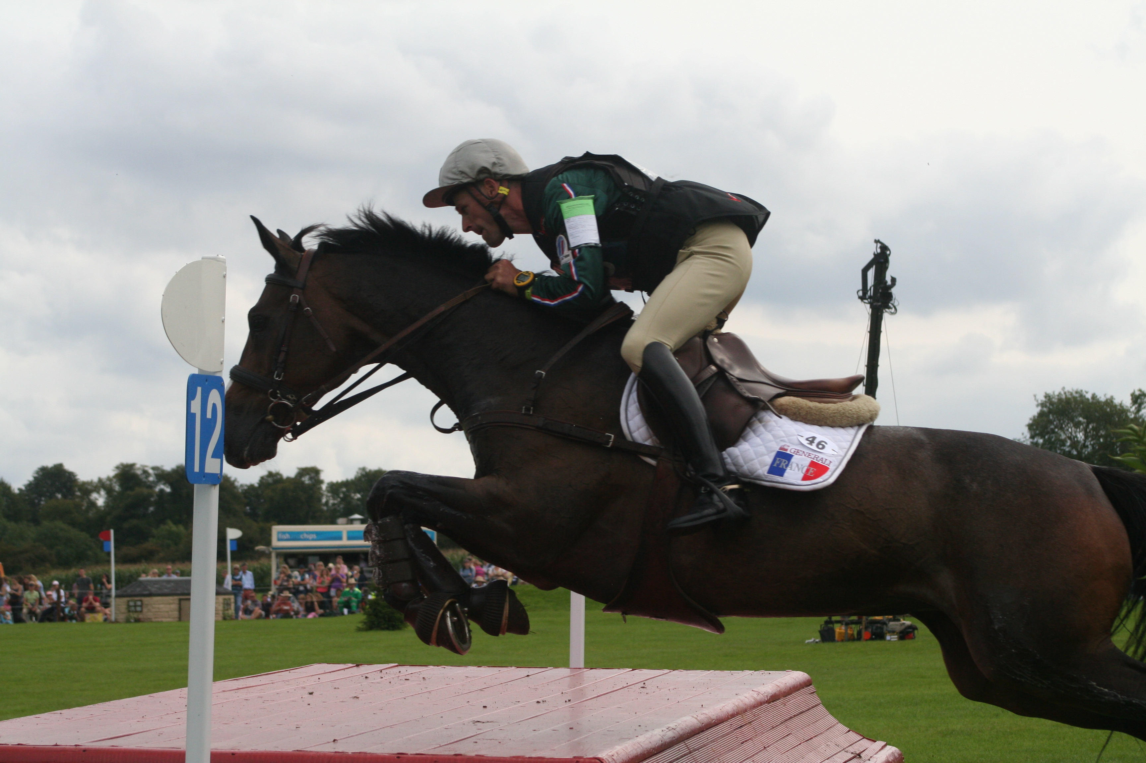

Recurrent azoturia;

These cases may need a more detailed investigation, which could involve checking blood and urine electrolyte levels, his diet and possibly muscle biopsies. Some horses can be managed successfully with dantrolene sodium, given by mouth. This is given approximately one hour before exercise and should be administered until the horse has returned to the level of exercise reached before suffering from azoturia. Dantrolene cannot be used while horses are racing or performing under Jockey Club or FEI rules.



The Acorns Equine Clinic, Pleshey, CHELMSFORD, Essex. CM3 1HU.
Telephone (01245 231152), Fax (01245) 231601.
Esseshorsevets.co.uk.

